

2021 TRANSPORTATION ALTERNATIVES

APPLICATION

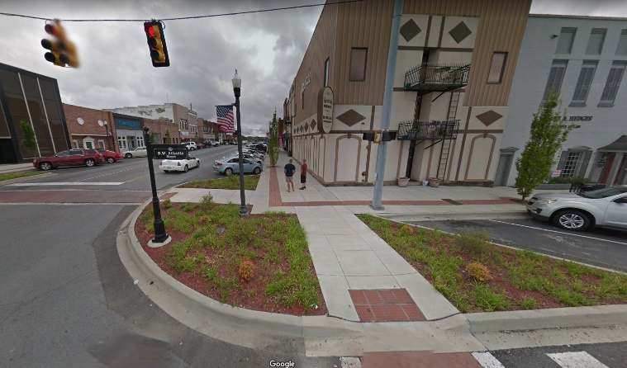
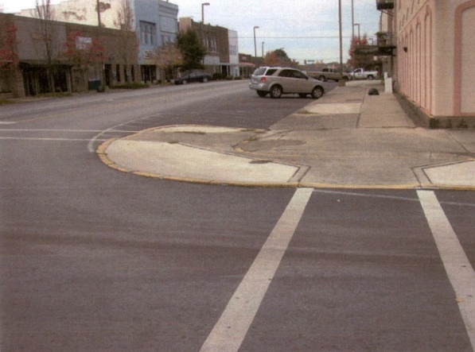

BEFORE

AFTER

Downtown Revitalization – Phases 1 & 2
Tullahoma, Coffee County

Example of Eligible Transportation Alternatives Program Activity One (1):
Bicycle and Pedestrian Facilities

Deadline for 2021 submittals:
October 2, 2020

Submit applications electronically via eGrants
https://tdot.intelligrants.com/Login2.aspx?APPTHEME=TNDOT&ReturnURL=/Module/TNDOT/TabSearch.aspx?NavItemID1=65692

TDOT – Transportation Alternatives Program (TAP) Office
Suite 600 James K. Polk Building
505 Deaderick Street
Nashville, Tennessee 37243-0341
Phone: 615-741-5314
2021 Transportation Alternatives Updates

- Please note that all applicants must formally submit through the eGrants system only.

- A Local Agency shall use TDOT’s prequalified consultants for every phase and follow TDOT’s approved Local Version of TDOT Consultant Selection Policy Form 1-2. In addition, a consultant advertisement template, Form 1-3 must be reviewed by the TAP Office prior to any solicitation.

- 2021 Transportation Alternatives Program (TAP) awards must be authorized for construction on or before July 1, 2024 or the funds will be withdrawn. No contract extensions can be provided by TDOT to secure the funding.

- All TAP projects, regardless of scope or complexity, must be designed per TDOT Standards for Roadway Design and Bridge Construction and be submitted in the required TDOT format, and all detectable warning systems/truncated domes must be universal safety yellow only.

- All bicycle & pedestrian facilities must be hard-surfaced, ADA compliant and provide adequate linear connectivity to existing facilities. Funding may not be used for spot improvements, repairs or maintenance unless a component of an approved ADA Transition Plan. All sidewalks must be a minimum of 5-feet wide and shared-use facilities must be a minimum of 10-feet wide.

- Newly constructed and altered facilities covered by Titles II and III of the ADA, including all TAP-type projects, must be readily accessible to and usable by people with disabilities per the Public Rights-of-Way Accessibility Guidelines (PROWAG).

- The 20% minimum non-federal construction share of the proposed project must be provided as a hard cash match. All preliminary engineering (NEPA and Design) and right-of-way expenditures are solely the responsibility of the local agency.

- Prior to submitting a 2021 application, all applicants must hold an application public involvement meeting to notify the local community of the intended project scope. The date(s) and time(s) of public meetings that were held as well as the sign-in sheet, the record of all public comments received and the disposition of said comments must be included with the completed application.

- If the proposed application is selected for project funding, only the specific description and approved budget items will be eligible for construction. TAP funding cannot be transferred nor is it eligible for major project scope changes. All unused federal funds will revert to TDOT for re-distribution in the next funding cycle.

- Applications and proposed design plans selected for award have not been fully vetted, reviewed or approved by TDOT and may require further modification.

Please access http://www.tn.gov/tdot/local-programs for The Local Government Guidelines for the Management of Federal and State Funded Transportation Projects manual, which provides State and Local Agencies with the procedures that are required by law, regulation, rule, policy and standards for the use of Federal Highway Administration (FHWA) transportation projects.

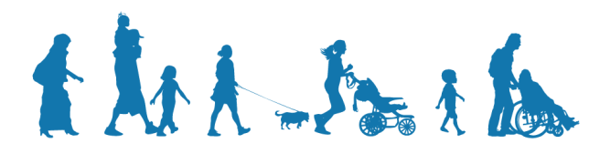

2021
TRANSPORTATION ALTERNATIVES
PROGRAM APPLICATION

Project Title: Click here to enter text.

Physical Project Address including 9-digit zip (not the address of applicant):
Click here to enter text.

Project County: Click here to enter text. Applicant Population: Click here to enter text.

Application Priority Ranking: Click here to enter text.

Is this a resubmittal of a previously non-awarded application? Y/N
Provide the year of last submittal: Click here to enter text.

Is the applicant within a Metropolitan Area with a population over 50,000? Y/N

If yes, please provide the MPO name: Choose One

Is the project within the MPO Urban Boundary? Y/N

- Total Construction Cost (100%): $Click to enter $
(excluding NEPA, design and right-of-way expenses)

- Federal Construction Funds Requested (maximum 80%): $Click to enter $
(excluding NEPA, design and right-of-way expenses)

- Local Cash Match of Construction Funds: $Click to enter $
(Minimum 20% of number 1)

Name of City/County or State Agency Applicant:
Click here to enter text.
Address: Click here to enter text.
Local Agency Contact and/or Responsible Charge Name, Title, Phone Number and Email Address:
Click here to enter text.

I hereby certify that, to the best of my knowledge, the information submitted with this application is accurate, all rules
and regulations contained in TDOT’s Local Government Guidelines for the Management of Federal and State
Funded Transportation Projects will be followed and that all funds, including the required 20% local cash match,
are now available for the completion of the project as described herein.

Signature: ________________________________________________ Date Click here to enter a date.

City or County Mayor or State Agency Head

Printed Name and Title of elected official: Click here to enter text.

THE HIGHEST ELECTED OFFICIAL OF THE LOCAL AGENCY MUST SIGN THIS APPLICATION

SECTION 1: TRANSPORTATION ALTERNATIVES ACTIVITIES

Check all that apply. Explanations of each activity can be found on page 4 of the instruction booklet.

Pedestrian and Bicycle Facilities & Safe Routes for Non-Drivers

- New or reconstructed sidewalks, walkways or curb ramps

- New or reconstructed ADA compliant greenways and off-road trails

- Bike lane striping

- Cycle tracks

- Wide paved shoulders for horse and buggy use

- Bike parking and bus racks

- Bike and pedestrian bridges and underpasses

Conversion of Abandoned Railway Corridors to Trails

- Construction of shared use trails within railroad rights-of-way

- Construction of rails-with-trails projects

- Bike parking

Scenic Turnouts and Overlooks

- Construction of scenic turnouts, overlooks and viewing areas

Historic Preservation & Rehabilitation of Historic Transportation Facilities

- Preservation of historic transportation buildings and facades

- Restoration of historic buildings for transportation-related purposes

- Access improvements to historic sites

- Restoration of railroad depots and bus stations

- Rehabilitation of rail trestles, tunnels and bridges

Archaeological Activities

- Projects related to archaeological assessments from implementation of current highway construction projects

SECTION 2: PROJECT DESCRIPTION INCLUDING PURPOSE AND NEED

PROJECT DESCRIPTION: Click here to enter text.

Include project name, project location, and scope of work. The project location should run from west to east or south to north and must include State and Federal routes as well as local road names. You must include a color-coded map that clearly delineates the project (with road names, a north arrow and the project location highlighted) and any photographs, drawings and applicable preliminary sketches. You must also provide a photograph of the beginning and ending termini if you are submitting for an Activity 1 or Activity 2 project. Please do not submit any documents larger than 8.5” x 11”.

If this is a bike/pedestrian facility, you must provide distinct and connecting termini (logical destination points such as federal/county/city offices, historic sites, schools, libraries, vehicular trailheads, etc.). Future unbuilt phases do not qualify as eligible destination points. Note that inadequate connectivity may affect TDOT design plan review and approval as well as the projected costs for construction.

Five-foot wide sidewalks are for pedestrian use only. Shared-use facilities must accommodate both pedestrian and bicycle traffic at a minimum of 10-feet wide. Connecting facilities, both proposed and existing, must accommodate both modes of transportation if applicable or connect to an approved trailhead (with adequate ADA parking) or terminate at an eligible destination point. All bicycle and pedestrian facilities must be ADA compliant and provide adequate linear connectivity to existing accessible facilities. Pedestrians cannot utilize bike lanes, and all pedestrian facilities must provide adequate separation from vehicular traffic based on TDOT Design Standards.

Funding may not be used for spot improvements, repairs or maintenance unless a component of an approved ADA Transition Plan. Address any questions concerning connectivity to the Transportation Alternatives Office at TDOT.Enhancements@tn.gov.

PURPOSE AND NEED:

FHWA requires a clear statement of identified objectives for improving alternative transportation conditions.

Connectivity: Provide a brief description of how the proposed project will increase connectivity among a mixture of land
uses and activity centers such as transit, residential neighborhoods, low-income housing, medical facilities, schools, retail, parks, employment centers, etc. Click here to enter Connectivity.

Social and Economic Impact: How will this project serve economically disadvantaged populations or aid economic development in the community? Click here to enter Impact.

Safety: Provide a brief description of how the proposed project will improve safety for pedestrians, bicyclists, and other transportation users. Click here to enter Safety.

SECTION 3: PROJECT BUDGET

Pending applications will not be selected for funding until the fall of the following year with most projects not proceeding to construction for an additional two or three years: please adjust your budget for inflation and verify your calculations.

The source of the matching funds that will be provided by the Local Agency cannot be from another FHWA surface transportation source. All cost overruns in excess of the awarded funding amount are the responsibility of the local agency. The minimum 20% non-federal share of the proposed project must be provided as a hard cash match.

All projects must be competitively bid and no additive alternates or deductions will be allowed in the final construction cost estimate or bid documents.

Standardized budget templates are available as a link in eGrants and located on the TAP website. Line items can be added or deleted as needed for any stage utilizing TDOT line item numbers when available; however, the TAP budget template must be used. Note: the structural template tab is for Historic Preservation and Rehabilitation of Historic Transportation Facilities only.

Access TDOT Line Item Numbers at https://www.tdot.tn.gov/APPLICATIONS/RoadwayItems

SECTION 4: INVESTMENT OF PUBLIC FUNDS

The project being developed must be maintained by the applicant and remain open to the public for a sufficient time commensurate with the federal investment as shown below:

Federal Amount Lease
$1.00 - $199,999 5 years from Federal close-out date
>$200,000 - $499,999 10 years from Federal close-out date
>$500,000 - $1,000,000 20 years from Federal close-out date

Projects over $1,000,000 carry a minimum 25 year lease and will be subject to individual review. Please note that the federal investment period begins once FHWA completes the final voucher for the project.

SECTION 5: SUPPORT AND PUBLIC INVOLVEMENT

Prior to submitting an application, all applicants must hold a design public involvement meeting to notify the local community of the proposed project scope. In addition, correspondence must be sent to the appropriate (MPO/TPO or Rural Planning Organization (RPO) describing the proposed activity and inviting input regarding the project. The date(s) and time(s) of public meetings that were held as well as the sign-in sheet, the record of all public comments received and the disposition of said comments must be included with the completed application.

Include the local, statewide, and legislative support for the proposed project, and attach any federal, state or local agency mandates or resolutions for the project.

Please provide all the legislative district numbers and legislator names that correspond to the proposed project location, NOT the address of the applicant

Senate District(s) No. Senate #s Legislator(s): Legislator Names

House District(s) No. House #s Legislator(s): Legislator Names

U.S. Congressional Representative District(s) No. US # Legislator(s): Legislator Name

SECTION 6: RIGHT-OF-WAY IMPACT

Is all property necessary for the project publically owned or leased? Y/N

Is the project along or adjacent to a State or Federal Highway? Y/N

Is any part of the project to be constructed inside State or Federal highway right-of-way? Y/N

Will the project impact an existing or eligible National Register Historic Site or District? Y/N

Will the project include a pedestrian/bike bridge or tunnel or impact an existing TDOT structure? Y/N

Will any part of your project (including parallel pedestrian facilities) impact a rail or trolley line? Y/N

TDOT will only accept applications through the eGrants system via https://tdot.intelligrants.com/Login2.aspx?APPTHEME=TNDOT&ReturnURL=/Module/TNDOT/TabSearch.aspx?NavItemID1=65692 . The submission must still include the necessary budget, detailed, maps, photographs, preliminary sketches and support letters.

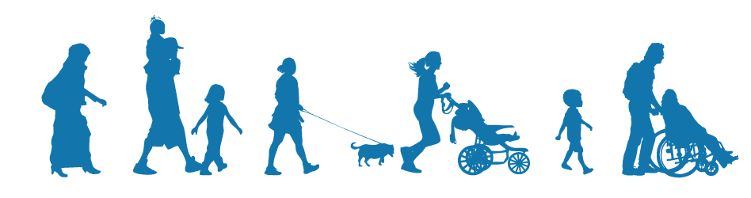

TDOT - Transportation Alternatives Program (TAP) Office
Suite 600 James K. Polk Building
505 Deaderick Street
Nashville, Tennessee 37243-0341
Phone: 615-741-5314

https://www.tn.gov/tdot/program-development-and-administration-home/local-programs/tap.html

