 Access to Health
through Built Environment

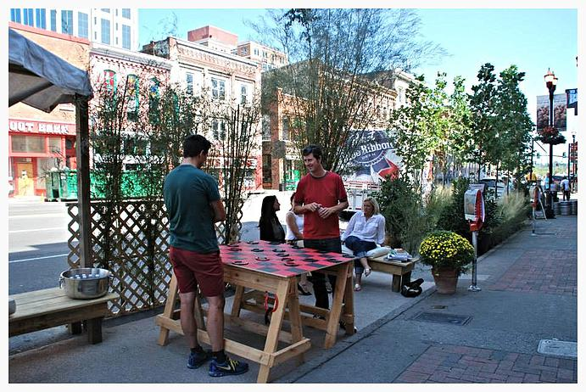 | 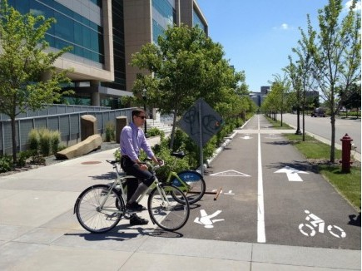 | 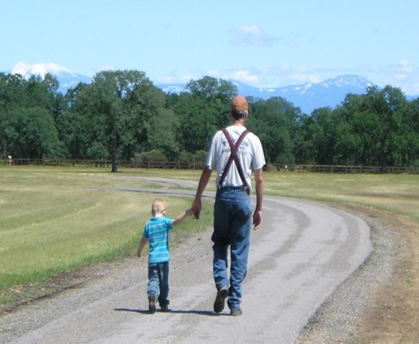

Report and Recommendations from
Rising Stars Team for Built Environment
May 27, 2015

Access to Health in Tennessee
Tennessee is ranked 45th overall in the United States in terms of health. Factors contributing to this ranking include high rates of obesity, physical inactivity, violence, and infant mortality. Aspects of the built environment can influence each of these key areas of health. In fact, improving the built environment can lead to an increase in physical activity and overall health and a reduction in violence, stress, length of hospital stay, asthma and infant mortality.,,, ,
Despite this, a survey of Tennessee communities showed that few Tennessee communities are considering health when making changes to the built environment. The Tennessee Department of Health can facilitate the inclusion of health in built environment decision-making, and promote built environment changes as a way to protect, promote and improve health and prosperity for people in Tennessee, by pursuing these strategies:
- establishing internal and external mechanisms for collaboration and decision-making;
- promoting “health in all policies,” to include consideration of built environment;
- identifying and leveraging opportunities to incorporate healthier design into planning of programs and infrastructure;
- expanding and sharing resources to support local communities;
- engaging individuals and/or partners with communications expertise to publicize need, resources, and impact; and
- supporting local communities to monitor, evaluate and report progress and outcomes.
Executive Summary
Although evidence shows that (1) place determines health and access to healthy options and (2) funding streams are emerging nation-wide to address built environment issues and their connection to public health, health remains on the periphery of built environment projects across the state of Tennessee. The Tennessee Department of Health could advance its mission to protect, promote and improve health and prosperity for people in Tennessee by leading and supporting built environment initiatives designed to prevent poor health outcomes, and by communicating opportunities and results.
There are currently many successful built environment projects and programs in Tennessee communities, which have been implemented through mutually beneficial partnerships at the local level. Coalitions of varied stakeholders, including business and industry, not-for-profit organizations, educational institutions, youth groups, faith leaders, government agencies, community organizations and others, are leading the charge for places that have something for everyone and that benefit all users. Some successful projects began by implementing small and temporary changes to how streets and public spaces look, and how they function. In this way, communities have enabled experimentation and learning “on the ground”. These successes can then be adopted by communities so that policies may be implemented and enforced. This ensures sustainability of community-led efforts. Other efforts begin with local champions and leaders who implement policies and institutionalize strategies that promote health through built environment initiatives. In Tennessee, there are examples of success arising from each of these approaches. A successful TDH strategy to advance built environment initiatives should utilize these lessons learned from across the state, encouraging and supporting local efforts through engagement with partners and development of supporting policies and resources at the state level.
Without staff support at the state and regional level, little can be done to affect positive policy, systems or environmental changes to shape the built environment. While many of Tennessee’s state departments have designated leaders and regional staff responsible for engaging with partners and aligning efforts in support of built environment projects, the Tennessee Department of Health currently has no executive-level leader responsible for built environment initiatives at the Tennessee Department of Health. Dedicated and qualified staffing is needed to ensure that health is considered and engaged in plans and actions concerning the built environment. Regional staff positions would further advance opportunities for collaboration with regional entities and local communities. TDH regional leaders would be able to support local built environment initiatives in three ways:
(1) For communities that have seen success with built environment pilot projects, TDH can scale up initiatives and help to solidify policies that would make built environment interventions part of a sustainable culture of health.
(2) For communities with plans for built environment projects, TDH can support rapid implementation of small pilot projects to test ideas and learn by doing.
(3) TDH can convene partners to create and align plans for immediate and long-term projects designed to promote health and prosperity through built environment.
By allowing variation in accordance with the status of the community’s infrastructure, regional coordinators can leverage resources from partners and stakeholders, in a way that is responsive to the local community’s readiness and capacity.
It will be essential to “tell the story” of built environment successes across the state if we are to have a lasting impact on health. Regional staff and local partners should be supported to enable monitoring and evaluation of projects and programs, and to share lessons learned and resources through a network of leaders building and sustaining livable communities. By raising awareness that Health should be considered in every building project, TDH will lay the cornerstone for a Tennessee where our people and our places support each other.

I. Background
- Expert Advisors from External Stakeholders
On December 11, 2014, Tennessee Commissioner of Health John Dreyzehner brought together leaders from diverse perspectives for a consultation meeting to discuss the connection between the built environment and health (Attachment 1 in Appendix). Dr. Dreyzehner asked the group to suggest ways in which the Department of Health could “move the needle” for population health improvement through built environment projects, enabling people to make the healthy choice because it is the easy choice.
Attendees at the meeting responded to three questions:
(1) How have our places positively affected our people’s health?
(2) How are we innovating, concerning the built environment?
(3) What role should the Tennessee Department of Health play in the future?

Individual stories about how built environments have improved health ranged from the street corner to the sector plan. Some discussed neighborhoods with safe sidewalks and places to play; others focused on the need for transit options and amenities. Neighborhoods and community leaders have advocated for improvements to greenways, bike lanes and trails while elected officials and planning departments have made active transportation infrastructure a requirement in development decisions.
Innovation occurs across the state, including projects initiated by County Health Departments as well as by other state agencies and local community programs. Funding opportunities exist across the board for built environment initiatives, from the federal level to the local level. Governments are seeking health funding to improve infrastructure in their cities and municipalities, and are increasingly using livability as a marketing tool. Community-level programs that focus on safe routes to school and local foods have promoted access to healthy and safe choices. Partnerships between government and non-profits are transforming underutilized land into destinations for physical activity and improved access to greenspace.
As a State entity, the Tennessee Department of Health has an opportunity to act as a convener and a facilitator in this movement. Cooperation and collaboration is needed to access funding for built environment projects, and also to engage with all stakeholders to ensure sustainability. TDH role should focus on engaging, educating and encouraging to grow support, successes and strong leaders.
There are existing efforts in the state that have modeled success in the built environment. We have a unique opportunity now to build on this momentum and to act strategically to position the Tennessee Department of Health as a leader in built environment initiatives which lead to better health.
B. “Rising Stars” team of leaders from public health
Commissioner Dreyzehner has established Rising Stars teams as a mechanism to encourage statewide sharing of ideas and give new leaders an opportunity to share their expertise in key public health issues. The Built Environment Rising Stars team was formed in February 2015 to research and recommend ways in which TDH could become more engaged with partners at the local and state level to promote health through shaping of the built environment (Attachment 2 in Appendix).
The Built Environment Rising Stars team was charged with

- defining approaches for TDH involvement to support local built environment initiatives as a primary prevention strategy, and
- recommending how TDH can lead and facilitate local innovation, and foster actions to
enhance the physical and social infrastructure supporting a culture of health for all.

Team members
Elizabeth Allen (TDH Family Health and Wellness, Chronic Disease and Health Promotion)
David Borowski (TDH Communicable and Environmental Diseases and Emergency Preparedness)
Rebekah English (TDH Northeast Regional Health Department)
Ben Epperson (Knox County Health Department, Healthy Kids Healthy Communities)
Michele Gourley (TDH Office of Minority Health and Disparities Elimination)
Cathy Montgomery (TDH Williamson County Health Department)
John Vick (Davidson County Metropolitan Health Department)

Liesa Jenkins (TDH Office of Grants Coordination and Strategic Alignment) served as Senior Leader and facilitator for the team.

During the course of their work, the team produced this report, based on their review of existing resources and their visits to identify and inventory community Bright Spots (Attachment 3 in Appendix). This report includes the team’s recommendations regarding potential strategies and roles for TDH and county health departments, as well as recommendations for a potential process and criteria to consider should funding be allocated to support activities that increase access to health through built environment projects (Attachment 4 in Appendix).

The team began as most do, discussing success stories, lessons learned and other considerations. Discussions ranged from small landscape features to large area plans and developments. Many resources were shared, reviewed and discussed. As a strategy for learning about current and potential “built environment” initiatives across the state, the team agreed to conduct site visits to various communities, in order to view both positive examples and lessons learned, and to identify challenges and opportunities that could be addressed. Each team member selected a location and scheduled a site visit for team members to meet with local leaders and to learn more about current and planned built environment projects and programs. An initial “checklist” with built environment indicators was used to guide discussions and assessment during each site visit (Attachment 3 in Appendix).

II. Considerations and Process
The concept of “Built Environment” is multi-faceted and complex, and can include everything from transportation infrastructure and public space to the interior spaces of workplaces and homes, each of which vary depending on the scale of the “community” being considered (i.e., block, neighborhood, city, county, region, etc.). Thus, team members needed to define the scope of our work, beginning with determining which aspects of the built environment we would consider. while air quality, access to farmers markets, , vehicle and pedestrian crashes, blighted properties, miles of bikeways and sidewalks, income, and access to care were all discussed as possible indicators to consider, we decided to focus on the public realm, including public open spaces, streets and public buildings.
The built environment serves many users and purposes, but is ultimately about people and their interactions with each other and with their physical (including both built and natural) environment. Health begins where we live, learn, work and play--in our families, neighborhoods, schools and jobs. The built environment impacts the social life of communities, including social capital and feelings of safety and empowerment. Built environment touches every aspect of people and their connection to place. Built environment includes many types of amenities in public spaces and works to affect their use. Connectivity, livability and social activity bolster economics, civics, safety and community image. Implementation of changes will be most successful if it engages communities, includes a diversity of partners and fosters collaboration across multiple sectors. An approach that works WITH communities instead of FOR communities will promote health equity and address health disparities.

Team members conducted site visits and interviews with local leaders in several different communities to learn about their projects, as depicted on this map:
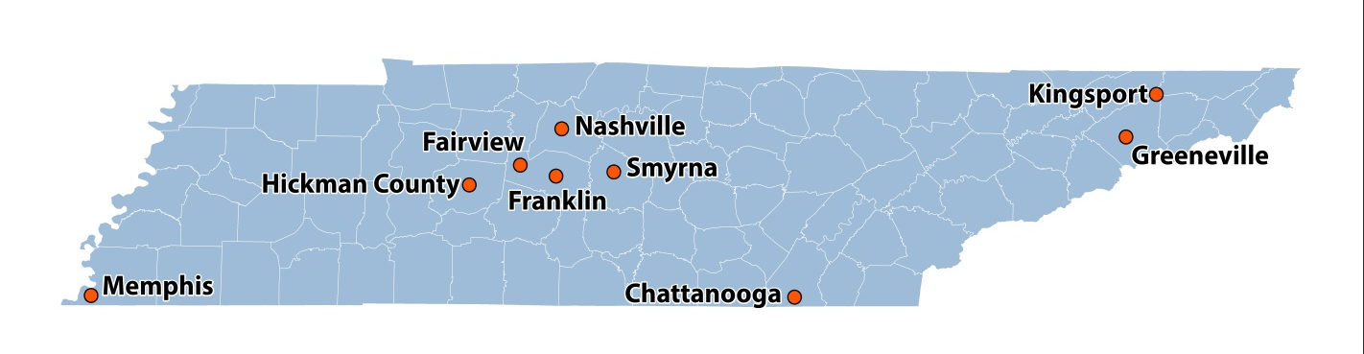
During site visits, the team experienced a range of built environment projects and programming, and visited with a diverse group of local leaders in each community. Key findings from each site visit are included in Attachment 3 in the Appendix.
We learned that most leaders think of built environment projects as one of two distinct but connected categories:
- Recreation-focused, with spaces and amenities that promote diverse activities. Recreation projects can be farmers markets, playgrounds, public art, landscaping, town centers, plazas, school yards, gardens or any public space where people mix.

- Transportation-focused, emphasizing connectivity, access and safety for all users. Transportation projects include but are not limited to greenways, sidewalks, bike lanes, lighting, streetscaping, transit features and traffic calming measures.
Interestingly, while most leaders perceived benefits from both economic and “quality of life” perspectives, most were not able to quantify the impact.
During these site visits, leaders described two distinct methods of funding and implementation of projects. The majority of resource-intensive, long-term initiatives were funded by governments (usually a combination of local and state funding, but sometimes included federal funding). On the other hand, smaller community-led projects utilized lighter, quicker and cheaper methods to pilot built environment interventions. Both grassroots and “grasstops” methods were successful in producing sustainable change. Community-led projects can experiment, giving governments much needed evidence and lessons learned on the ground. Sustainable projects successfully leverage support and data to influence changes in policy, systems and environment. Both grassroots and “grasstops” methods are needed for sustainable change.
No communities planned or implemented projects in isolation. Even cities that fully funded streetscape improvements did so with tax revenue from local industry or grant funds from state partners in transportation, and the most successful projects involved a large number of partners. Although some projects did have health partners, supporting with funding or data, health was not the impetus for initiation of the projects we encountered. Disappointingly, health departments were rarely at the table, but community leaders in each site expressed interest in working with local and regional health departments in the future.
The Rising Stars also collected informational resources and tools from a wide variety of sources (websites, articles, reports, research, project case studies and conference materials), and shared those resources by others on the team. These resources have been collected and compiled for use by others who wish to learn about built environment concepts and models (Attachment 6 in the Appendix), and can serve as the foundation for a publicly-accessible repository of information for others in the state.
III. Analysis of Observations and Lessons Learned
After conducting and sharing information gathered from research, observation and interviews, team members shared their observations, and reached the following conclusions:
- Built environment projects often contain multiple facets, not simply the need to improve transportation. Place-based amenities support active transportation (benches, lighting, trees, etc.), improving public safety, encouraging physical activity and health, and increased economic benefit to the community.
- Outside of the major urban areas, planning often seems to occur ad hoc. The short-sightedness of planning efforts harms health and economies in the long run. There is a need for resources and technical assistance to support longer-term planning efforts that include considerations of health and livability.
- Most built environment projects across the state had not considered the health impact of their projects, even though they recognize the benefits of doing so once the question was asked.
- The majority of built environment successes began as pilot projects, not top-down policy decisions. First come the ideas; then the action; then the policy.
- Community-led initiatives move forward faster. These efforts are often led by a local champion, who then mobilizes additional resources.
- Community engagement efforts are often under-staffed or lacking in staff altogether.
- Partnerships drive every success. A diverse set of stakeholders broadens the available knowledge, resources and impact.
- Community education can be an important asset for built environment initiatives. Engaging government officials, community members and leaders from the private sector offers opportunity to educate them on the health benefits of a supportive built environment.
Throughout the course of its work, the team reached consensus on “guiding principles” to be considered when making decisions about strategies and tactics to support access to health through built environment activities:
- Health in all policies
- Define “built environment”
- TDH and other state agencies should be models of health (buildings should be “healing spaces”, not impersonal warehouses)
- Accessibility (“everyone deserves health and a good living environment”)
- Health equity—invest in communities with greatest need and least capacity, provide technical assistance and resources
- Work in and with communities, not just from Nashville. Local presence matters.
- Support peer learning, mentoring, sharing
- Educate, don’t mandate
- Build partnerships and relationships to increase sustainability
- Communicate by “telling the story.” Interpret data for the layman, framing and sharing successes and lessons learned. Recognize progress (through an awards program)
- Demonstrate success through small, rapidly deployed projects, which can then lead to bigger projects, more support, and policy change as measures of sustainability and institutionalization
- Use data to show that it is making a difference, including financial / health / social
- If TDH wants this to happen, funding and personnel must be allocated

IV. Recommended Strategies
It is our perception that a network of built environment leaders, working together to build healthy places, will best support communities across Tennessee. Some of Tennessee’s communities are just starting out, while others are leading the movement nationwide. Every community has something to share and something to learn. By bringing public health to the discussion as a partner in regional and local efforts, we will begin to leverage resources and support for policies, systems and environments that make the healthy choice the easy choice for all Tennesseans. This approach includes six strategies, each supporting the others. All are essential to success.
Strategy 1: Leadership and Governance
Currently there is no designated leader or staff to support Built Environment initiatives at the Tennessee Department of Health. There are, however, portions of TDH that support built environment projects and programs across the state. Without designated staff, focused on a long term strategic goals for built environment, little can be done to accomplish broad policy, systems or environment change. In addition, there are very few staff positions at local or regional health departments in Tennessee who focus on Policy, Systems and Environment change. Capacity is limited in most county health departments to accept, train and support built environment professionals focused on prevention, planning and policy.
A TDH leader, with the ability to make decisions at the executive level, is needed to drive forward a vision for built environment strategies, and could serve as a member and / or facilitator of an interagency “livability task force” to coordinate and align efforts among state agencies.
Ideally, this director should be supported by 8-10 program management staff, located across the state, housed at regional and metro health departments. It is possible that qualified regional coordinators already exist in some capacity. Regional built environment staff could be responsible for networking and collaborating with stakeholders at a regional level to develop and sustain projects and programs in their regions. There is a current precedent in the state for regional staff support for strategic initiatives. Regional staff positions exist for built environment projects within the departments of transportation, environment, and economic and community development. Collaboration among these agency staff should occur at the regional level, to move built environment projects forward.
With a state director for built environment and regional staff managers, there is an opportunity to support both state level and regionally-focused livability teams, charged with aligning and leveraging resources to support mutually beneficial projects and programs.

Strategy 2: Policy
Built environment projects and programs have a short term impact if they are not integrated with policies established by governmental entities. To ensure sustainability, governments, partners and communities will need to support, implement and enforce built environment policies that positively impact community health. The Governor’s program for Customer-Focused Government has begun the work of examining how each state agency addresses health through its policies, as well as its programs and infrastructure; the information arising from the work could not only provide a framework for state-level policy development and implementation to promote “health in all policies,” but could also serve as a model for governmental entities at local, county and regional levels.
Often there is little model language or evidence readily available to policy makers when considering or adopting policy changes. A list of effective policy examples is needed to share evidence-based practices with policy-makers (city / county mayors and planning officials) and their stakeholders. The compilation and dissemination of these policies will enable effective communication concerning the connections between built environment and health and will build state-wide support for policy change.
Strategy 3: Strategic Planning and Alignment
Information gathered from local leaders revealed that there exist many plans relevant to built environment, including transportation, parks and recreation, housing, industrial and economic development, and agriculture; however, these plans are seldom integrated into a “master plan” for the community, nor are they always aligned with plans at the regional and state levels. Local leaders should be first consider any existing plans, and determine whether they are comprehensive and address the needs and opportunities for alignment of health and built environment strategies, and then act accordingly.
A “top down” approach would not be the most successful course of action. Built environment projects are often costly. Implementing system level policies without evidence of success “on the ground” will be a hard sell to communities and leaders. If we are to be successful in our efforts with policy makers, stakeholders and communities, we will need to show rather than tell. Small pilot projects, rapidly implemented and readily scalable, will demonstrate built environment concepts without requiring large scale financial support or permanent changes to infrastructure. Health departments and other partners, through collaboration, can support these small built environment pilot projects without municipalities and governments taking on the risk of failure. Healthy design trials can be implemented at any scale. Some communities will find it beneficial to start at their local health departments, showcasing the connection between place and health. No matter what scale is implemented, successes and lessons learned should be expanded and replicated as part of the strategic plan and then institutionalized going forward.
Strategy 4: Expand Resources
Regional health departments will soon have designated regional coordinators for planning and assessment. These types of positions are sometimes staffed at metro health departments as well. This trend is not unique to health across the state. Regional coordinators exist across many systems. Peer networking among regional partners, in parks, transportation, etc. will enable the conservation and strategic use of resources for built environment changes.
Built environment projects at the local level are often supported by smaller, localized partnerships and coalitions. Because built environment projects impact dimensions other than health, their funding sources are diverse. Most large funders (including foundations) that support health initiatives now require a coalition or collaborative efforts in order to qualify for funding. Collaboration at the local level, facilitated and supported by TDH regional coordinators, will enable communities to identify and secure resources. This collaboration will strengthen the number and quality of projects and programs in support of built environment change.
Ability to secure resources varies widely across the state, and typically corresponds to the community’s level of readiness to plan, implement, and evaluate projects. Regional partnerships, focused on coordination and planning, can meet communities at their capacity level. Technical assistance services could be provided for communities in the planning stage, offering peer knowledge, expertise and tools (such as the “checklist” included as Attachment 4 in the Appendix) from around the state. Some communities will benefit from catalyst funding, enabling and supporting initial pilot projects. Communities that have already implemented successful built environment projects will benefit from support to scale up and institutionalize projects and policies, including indices of indicators and tools to measure impact (health, economic, and other). TDH should consider a process for soliciting proposals and allocating funds to support communities at varying levels of readiness (as reflected in Attachment 5 of the Appendix).
Strategy 5: Communication
We must articulate the connection between health and the built environment. Local health departments are often not aware of nor are they acting on the evidence that design influences population health. Identifying and documenting built environment success stories, of both people and places, will assist in broadening awareness and engagement for this topic. A communications plan must be an essential component of a built environment strategic plan, and must address multiple audiences (such as policy-makers, potential funders, planners, builders, volunteers and users). Framing of the message should include the promotion of economic benefits, livability solutions, community character, unique Tennessee resources and other positive, politically neutral messages. The communications plan should also leverage multiple distribution channels, including traditional media and websites, but also leveraging social media and other means of reaching diverse audiences.
Strategy 6: Monitoring and Evaluation
For all the built environment successes in Tennessee, there remains a scarcity of data available concerning performance measures. TDH can not only provide relevant data to communities seeking to measure health impact, but could also provide technical assistance to communities to identify indicators and use checklists to assess their health. TDH can train local and regional teams to conduct monitoring (to inform short-term decision-making) and evaluation (to inform long-term decision-making) for their efforts. By training local and regional teams, TDH can support ongoing performance excellence for projects and programs, and sustain improvements in health and health-related outcomes by helping to gather and analyze data, and by communicating successes which could serve as a model for communities in Tennessee and elsewhere while also attracting additional resources to fund evidence-based initiatives.

V. Conclusion
In summary, the Rising Stars team has learned that local and state-level leaders recognize the benefit of articulating and measuring the impact that built environment could have on health in our state, and welcome the engagement of public health as a partner in planning, developing, and sustaining initiatives that increase access to health through built environment projects.
There is strong support for TDH to serve as convener of a state-level interagency “livability” team, while also participating in regional collaborative planning activities and providing technical assistance and resources for local community leaders and projects. Documenting and communicating successes will lend support for policy change, infrastructure development and long-term sustainability.
TDH should consider allocation of resources (executive-level director, regional coordinators and possible funding for projects that align with the community’s level of readiness) to help strengthen collaboration and impact by working with and for communities at the local level, thereby building a foundation for long-term improvement in health and prosperity for people in Tennessee.

America’s Health Rankings 2014. State Data: Tennessee Overview. http://www.americashealthrankings.org/TN. Accessed May 6, 2015.
America’s Health Rankings 2014. State Data: Tennessee Measures. http://www.americashealthrankings.org/TN Accessed May 6, 2015
Guide to Community Preventive Services. Environmental and policy approaches to increase physical activity: community-scale urban design land use policies. www.thecommunityguide.org/pa/environmental-policy/communitypolicies.html Accessed May 7, 2015
Yue, X., Vessel, E.A., Biederman, I. (2007). The neural basis of scene preferences. NeuroReport, 18(6), 525-529
Kuo, F.E. (2001). Coping with poverty: Impacts of environment and attention in the inner city. Environment & Behavior, 33(1), 5-34.
Ulrich, R.S. (1984). View through a window may influence recovery from surgery. Science, 224(4647), 420-421
Ulrich, R., Zimring, C. (2004). The Role of the Physical Environment in the Hospital of the 21st Century: A Once-in-a-Lifetime Opportunity. Robert Wood Johnson Foundation Report.
America’s Health Rankings 2014. Air Pollution United States. http://www.americashealthrankings.org/ALL/air Accessed May 6, 2015

