Purchasing, Receiving and Storing of Foods
Used in School Nutrition Programs
Purpose: To ensure that all food is received fresh and safe when it enters the foodservice operation, all food is transferred to the proper storage as quickly as possible, and to ensure that all food is stored in a manner that maximizes both quality and safety of the food served. All of the following charts and information should be added to current Standard Operating Procedures (SOP) found in your local Hazard Analysis Critical Control Point (HACCP) Plan. Refer to the local “Receiving Deliveries” and “Storage” (of food items) SOPs.

Instructions:
  - Train foodservice employees on using the updated local procedures. This procedure applies to foodservices employees who receive and store food.
  - Follow state or local health department requirements.
  - Insert charts and information in the appropriate local SOP(s).

Purchasing And Receiving | Monitoring  Frequency
All food is procured from an approved source. The ____________ (Insert District Name) School Nutrition Program will ensure that all foods served to students, including food from the school garden and local farmers, are safe from biological, chemical, and physical hazards. The ___________ (Insert District Name) Central Office will identify and approve the sources. | Annual and as needed
Temperature-controlled delivery vehicle(s) used to deliver foods to the school(s) and/or the warehouse is clean. Refrigeration vehicles must be at 41ºF or colder and frozen storage vehicles must be at 0ºF. These conditions are addressed in the ____________ (Insert District Name) bid conditions. | As needed; observation of food(s) delivered
Food is inspected within 10 minutes of delivery using the criteria outlined in Table 1: Criteria for Accepting or Rejecting a Food Delivery. Food that is rejected is segregated from all other items until returned to the vendor. | As needed – note on invoice
The temperature of refrigerated and cooked foods is taken within 10 minutes of delivery using the guidelines outlined in Table 1: Criteria for Accepting or Rejecting a Food Delivery. Frozen foods are checked to be sure they are rock solid and no water marks appear on the packaging. Food not at proper temperature is segregated from all other items until returned to the vendor. | As needed – note on invoice
No past-dated foods are accepted. This includes foods labeled “Sell By, Expiration Date, Best If Used By, and Use By.” | As needed; observation of food(s) delivered

Table 1: Criteria for Accepting or Rejecting a Food Delivery
Food | Criteria to Accept Delivery
Meat and Poultry | 41ºF or colder.  Stamped with USDA inspection stamp.  Good color and no odor.  Packaging is clean and in good condition and no signs of tampering and/or counterfeiting.  Not past dated.
Seafood | 41ºF or colder.  Good color and no off-odors.  Packaging is clean and in good condition and there are no signs of tampering and/or counterfeiting.  Not past dated.
Fresh Produce | Clean and in good condition and no signs of decay or spoilage.  No signs of tampering.  If produce is cut or processed, it is at 41ºF or colder.
Dairy Products | 41ºF or colder.  Packaging is clean and in good condition and no signs of tampering.  All products are pasteurized.  Not past dated.
Eggs | Shell eggs at 45ºF or colder; liquid eggs at 41ºF or colder.  Shell eggs -- clean and uncracked; frozen and dry eggs – pasteurized.  Packaging is clean and in good condition and no signs of tampering and/or counterfeiting.  Not past dated.
Refrigerated and Frozen processed food | 41ºF or colder; if frozen, the product is rock solid.  Packaging is clean and in good condition and no signs of tampering.  Not past dated.
Canned Food | No swollen ends, leaks, rust, or significant dents.  Label can be read and is attached to the product.  No signs of tampering.  Not past dated.
Dry foods | Packaging is clean and in good condition and no signs of tampering.  No signs of pest infestation.  Not past dated.
Baked Goods | Packaging is clean and in good condition and no signs of tampering.  Products are not moldy.  Not past dated.
MAP (modified atmosphere packaging) | If the product requires refrigeration, it is at 41ºF or colder.  Packaging is clean and in good condition and no signs of tampering.  Labels can be read and attached to the product.  Not past dated.
UHT | Packaging is clean and in good condition and no signs of tampering.  If product requires refrigeration, it is at 41ºF or colder.  Label is attached and can be read.  Not pasted dated.

Dry Storage | Monitoring  Frequency
Brown box food items including USDA Foods and commercially packaged food – label items with a permanent black marker with date received (month/year) in a conspicuous location on the package or label with a permanent black marker each individual can/container with the pack date that appears on the case (month/year). The date-marking option to use is a local decision. As cases are opened, transfer the date to the individual units that remain in inventory. The date that the USDA Food is received at the facility may be used for date-marking. | Upon delivery receipt and as needed
A first in, first out (FIFO) procedure is used for all dry food storage. | Daily
All food is stored on clean shelving that is at least 6 inches off the floor. | Daily
The temperature(s) of the dry storeroom(s) is between 50ºF and 70ºF and is clean, dry, and well-ventilated. | Daily
Food is stored in durable, food-grade containers that are not stored in direct sunlight. | Daily
Cleaning supplies and other chemicals are completely separated from all food, dishes, utensils, linens, and single-use items. | Daily
Non-food supplies and chemicals are in their original containers. If not in the original container, the item is clearly labeled on the side of the holding container with the name of the contents. Do not label the lid because lids are interchangeable. Some chemical suppliers provide labels. | Daily

Refrigerated Storage | Monitoring  Frequency
Food is stored to allow for good air circulation. Shelves are not lined with foil or other materials. | Daily
A refrigerator thermometer is on the top shelf near the door of the refrigerator. The temperature of the refrigerator is at 41°F or below. The temperature of all time and temperature controlled foods (formerly potentially hazardous foods) must be at 41ºF or below. | Daily
Critical Control Point -- Cooked and ready-to-eat foods are stored above raw foods in the refrigerator. Foods are stored in this order:  - Prepared or ready-to-eat food (top shelf)  - Raw fish, seafood items, eggs  - Raw beef/steak cuts (sirloin, ribeye, T-bone)  - Raw pork (bacon, pork chops)  - Ground or processed meats (hamburger)  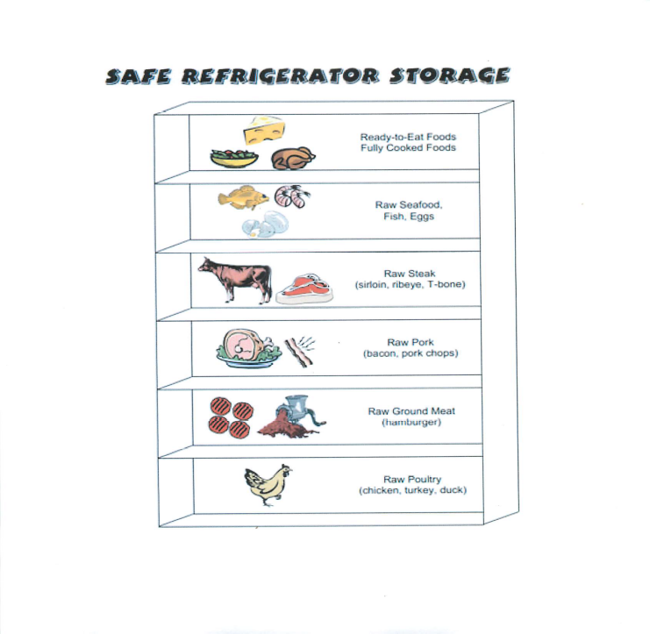  - Raw and ground poultry (chicken, turkey, duck)(bottom shelf) | Daily

Frozen Storage | Monitoring  Frequency
Freezers are defrosted according to manufacturer instructions. NOTE: Manufacturer instructions should be available for all equipment. | Monthly
A freezer thermometer is placed near the front of the freezer on the top shelf. The temperature is 0ºF or below. | Daily

Frozen Storage Tidbits
Is Frozen Food Safe? | Food stored constantly at 0 °F will always be safe. Only the food quality suffers with lengthy freezer storage. Freezing keeps food safe by slowing the movement of molecules, causing microbes to enter a dormant stage. Freezing preserves food for extended periods because it prevents the growth of microorganisms that cause both food spoilage and foodborne illness.
Freshness & Quality | Freshness and quality at the time of freezing affect the condition of frozen foods. If frozen at peak quality, thawed foods emerge tasting better than foods frozen near the end of their useful life. Store all foods at 0° F or lower to retain vitamin content, color, flavor, and texture.
Packaging | Proper packaging helps maintain food quality and prevent freezer burn. It is safe to freeze meat or poultry directly in its original packaging, however, this type of wrap is permeable to air and quality may diminish over time. For prolonged storage, overwrap these packages as you would any food for long-term storage. It is not necessary to rinse meat and poultry. Freeze unopened vacuum packages as is. If you notice that a package has accidentally been torn or has opened while food is in the freezer, the food is still safe to use; merely overwrap or rewrap it.
Freezer Burn | Freezer burn does not make food unsafe, merely dry in spots. It appears as grayish-brown leathery spots and is caused by air coming into contact with the surface of the food. Cut freezer-burned portions away either before or after cooking the food. Heavily freezer-burned foods may have to be discarded for quality reasons.
What if a food is not listed on Table 2? | If a food is not listed on the chart, you may determine its quality after thawing. First check the odor. Some foods will develop a rancid or off odor when frozen too long and should be discarded.
What if my district does not have timeframes for storing foods? | Each local district should develop procedures for the storage of all foods. These procedures should include the timeframes and conditions for the storage.

Table 2: Because freezing keeps food safe almost indefinitely, the recommended freezer storage timeframes are for quality only. Frozen foods remain safe indefinitely. The chart is from the United States Department of Agriculture (USDA) Food Safety and Inspection Service. The storage times listed below are approximate months of storage for some food products assuming the food has been prepared and packaged correctly and stored in the freezer at or below 0°F. For the best quality, use the shorter storage times.

General Guidelines for Freezer Storage Chart (0 °F):
Item | Months
Bacon and Sausage | 1 to 2
Casseroles | 2 to 3
Egg Whites or Egg Substitutes | 12
Frozen Dinners and Entrees | 3 to 4
Gravy, Meat or Poultry | 2 to 3
Ham, Hotdogs and Lunchmeats | 1 to 2
Meat, Uncooked Roasts | 4 to 12
Meat, Uncooked Steaks or Chops | 4 to 12
Meat, Uncooked Ground | 3 to 4
Meat, Cooked | 2 to 3
Poultry, Uncooked Whole | 12
Poultry, Uncooked Parts | 9
Poultry, uncooked giblets | 3 to 4
Poultry, cooked | 4
Soups and Stews | 2 to 3
USDA Food | 6*
*The recommended timeframe for USDA Food is to not exceed six months’ of inventory. There are circumstances where USDA Foods will be held longer. Use the guidelines listed above.

Date Marking Ready-To-Eat Foods | Monitoring  Frequency
Label ready-to-eat, time/temperature control for safety foods that are prepared on-site and held for more than 24 hours. Label any processed, ready-to-eat, time/temperature control for safety foods when opened if they are to be held for more than 24 hours. The best practice for a date marking system would be to include a label with the product name, the day or date, and time it is prepared or opened. | Daily
Refrigerate all ready-to-eat, time/temperature control for safety foods at 41 ºF or below. | Daily
Serve or discard refrigerated, ready-to-eat, time/temperature control for safety foods within 7 days. Calculate the 7-day time period by counting only the days that the food is under refrigeration. | Daily
Freezing food stops the date marking clock but does not reset it. Frozen time/temperature control for safety foods must be marked with the number of days held in refrigeration prior to freezing and dated when the food is removed from the freezer to limit consumption within seven calendar days, including the day of preparation or opening original container from a food manufacturer. If a food is stored at 41º F for two days and then frozen at 0º F, it can be safely stored at 41º F for five more days after removal from the freezer. | Daily
Avoid mixing different batches of foods that were opened on different dates. | Daily

