Therap Guidance Document
Information for ISCs and DIDD Case Managers
Last updated: Aleah Glodich
5-8-2024



Table of Changes
Date | Author | Description
10/1/2022 | Courtney Kelly | Initial Draft
11/5/2022 | Courtney Kelly | Added Screen Shots
11/22/2022 | Oileen Roberts | Modified formatting
12/1/2022 | Oileen Roberts | Added cover page, table of changes, table of content
12/2/2022 | Oileen Roberts | Added the FAQ to the glossary, How to Admit/Discharge an Individual. Added decision on which questions on the PFW will be pulled into the PCSP.
12/6/2022 | Oileen Roberts | Modification to the Change Form process
12/7/2022 | Oileen Roberts | Changing an Individual from one Support Coordinator to Another; add table for ISC/DIDD CM Provider Codes
12/12/2022 | Courtney Kelly, Bo Hickman, Brandi Osborne, Kathleen Chapman, Kimberly Black, Oileen Roberts | Review document together, modify wording and placement of screen shots.
12/15/2022 | Kathleen Chapman, Bo Hickman, Brandi Osborne, Scott Mullins, Kimberly Black, Oileen Roberts | Finalized the last portion of the document.
12/20/2022 | Oileen Roberts | Updated the List of Options for the Reason for Change field on the Change Form.
1/17/2023 | Oileen Roberts | Added comments to PFW page. DIDD will not use initially.  Add API section in Appendix to list fields overwritten by the API. Started Section “Return for Clarification”
1/20/2023 | Oileen Roberts | Completed the RFC section, add comment to Participant section of PCSP instructions.
1/24/2023 | Oileen Roberts | Embed document with list of Core Fields in Glossary
1/25/2023 | Oileen Roberts | Add screens shots of the PFC and additional steps to section.
1/26/2023 | Oileen Roberts | Adding details to RFC from Emails by PR group
1/31/2023 | Oileen Roberts | Replace Screen Shots on pages 15 and 16
6/22/2023 | Brandi J. Osborne | Reviewed document, updated wording, and added screenshots.

Contents
Table of Changes 1
Therap PCSP Guidance Document 3
Log In to Therap 3
Individual Demographic Form 4
Personal Focus Worksheet 9
The Person-Centered Support Plan 10
The Questionnaire 18
Submitting the Plan 26
Return for Clarification 28
Change Process 30
Submitting a Change Form 33
Creating a New Plan from an Existing Plan 35
How to Assign CM Provider 36
Creating a DIDD Caseload by Region 38
Appendix 44
Core Fields 44
Therap Roles: Supervisors Guide 44
How to request Access to Therap 45
DIDD Naming Convention for Therap Documents: 45
Changing an Individual’s Support Coordinator 47
Discharge an Individual 47
ISC Provider Codes 48
Acronyms and Abbreviations Definitions 50
Frequently Asked Questions 52

Therap PCSP Guidance Document
November 2022

Case Management Go Live Date: March 1, 2023

Log In to Therap
- Three pieces of information plus the URL will be needed to log into Therap.
- URL: Therap :: Login (therapservices.net)
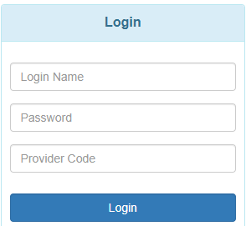
- Your credentials: This will be provided to you by the person who sets up your account, usually the DIDD Help Desk, for DIDD employees, or by your systems Super Admin for ISC agencies.
  - Login Name
  - Password
  - Provider Code
- Your provider code will be based on who you are employed by. Each ISC agency will have its own provider code. DIDD Case Managers will also have their own provider code.
- Enter all three pieces of information then click the Login button to get to the Therap Dashboard.
- If you are logging in for the first time, you will be presented with the screens to change your temporary password to a more permanent password.

Individual Demographic Form
- Switch to your Oversight Access Profile in Therap.
DIDD Case managers and ISC Case Managers should always use the Oversight and Providers profile to create the PCSP. This allows them to have some of the configuration benefits that have been specifically created for/approved by DIDD. If the case managers try to update from their case manager account, some of the benefits in the oversight account is lost. In particular, a document attachment on the PCSP from the oversight will allow up to 10MB. If the access is via the ISC/CM account, it only allows a 3MB attachment.

- For your Individual, Complete the Individual Demographic Form (IDF). The first time may take a bit longer. Subsequent times you will only update the information that may have changed.
  - Verify that the information is correct for the following fields. Please DO NOT CHANGE this at the oversight level. It will be overwritten by the API feed from TennCare. See the Appendix for a longer list of fields that are overwritten by the data from TennCare.
    - Name
    - Birth Date
    - Medicaid Number
    - Social Security Number
    - Telephone Number
    - Residential Address
    - Mailing Address
If you need to update any of these fields, you need to (1) contact TennCare to get corrections made in the TennCare Connect Portal, and/or (2) If your individual receives Supplemental Security Income (SSI), you will need to contact Social Security to correct any of these fields with them.
  - Complete the Allergy Profile if necessary
    - Click on the “Add Allergy Profile” at the bottom of the page 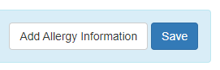
    - Complete the form’s required fields (*) and any other fields for information you have.
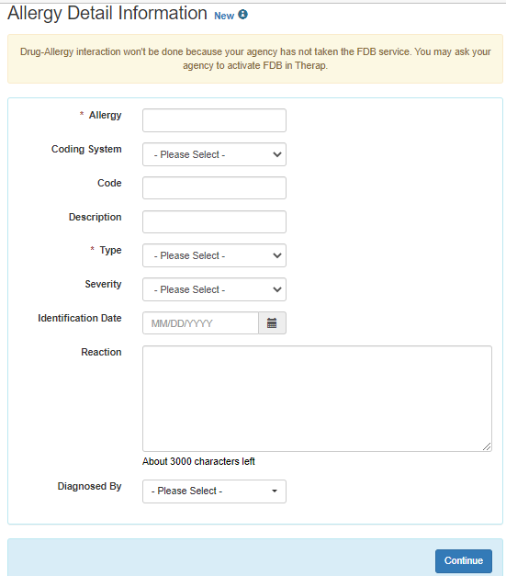
    - Click Continue - NOTE: only two fields are required on this page.
    - Click Save on the next screen to not lose the information you entered.
  - Complete the Individual Diagnosis List
    - Click Create New to open the form
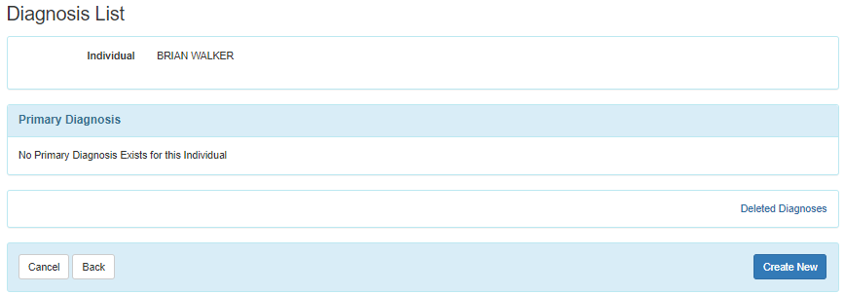
    - Enter “Intellectual” in the Lookup Diagnosis Code field
    - The system will provide the list of ID Diagnosis codes (as shown below)
    - Select one from the list
    - If this is the primary diagnosis for the person, click the box next to Is Primary Diagnosis?
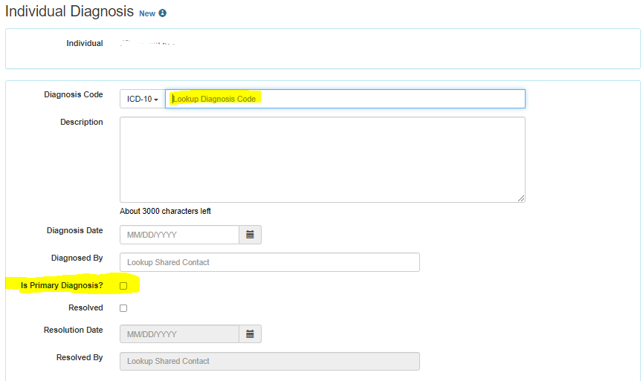
    - Click Save at the bottom of the screen.
Diagnosis: Users need to complete with Primary Diagnosis that got the person into service. This is important for the Billing/Claims process. Users can add as many diagnoses as necessary, however one must be tagged as the primary diagnosis.

ID Diagnosis Codes
- F70 Mild intellectual disabilities
- F71 Moderate intellectual disabilities
- F72 Severe intellectual disabilities
- F73 Profound intellectual disabilities
- F79 Unspecified intellectual disabilities

NOTE: For Katie Beckett Children please use F79 Unspecified Intellectual Disabilities

  - Review and update the individual’s Contact List
    - Click Add New Contact link to open the form to add a contact
    - Add as much information as is available to the form
    - Indicate if this is a Guardian by clicking the box next to Is Guardian
    - If a new contact is a guardian, you will need to complete additional fields. You can upload supporting documentation for Conservator, Ad Litem, etc. to the contact record. See Appendix for DIDD file naming standard.
    - Options for Guardian Type include:
      - Ad Litem
      - Advocate
      - Conservator
      - Limited
      - Plenary
      - Other – if other is selected you will also need to complete the If Other field.
    - Options for Guardian Authority include the following and is multi-select
      - Financial
      - Legal
      - Medical
      - Residential
      - Vocational
    - Click Save at the bottom of the screen – NOTE: Contact List can be exported to Excel.
  - Add Team Members and tag the Legal Decision Maker(s)
    - Click Add Team Member at the bottom of the screen to create a new record
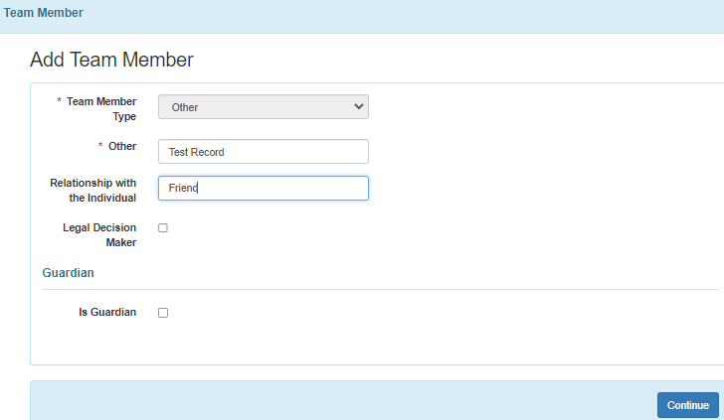
    - Click box next to Legal Decision Maker or Is Guardian, if those options apply to this new team member, otherwise leave unchecked.
    - After adding all the information, Click Continue to save the record
    - Click Update which will add the latest new record to the persons list of team members.
  - If available, add Shared Contacts to the individual
    - DIDD has made the decision to defer use of this field at this time.
    - This is where a professional or hospital could be entered once, then selected for multiple individuals.
    - Shared Contact is opened for use by the Public ICFs.
  - Review the Custom Fields for your individual are correct
    - The custom fields for DIDD include these
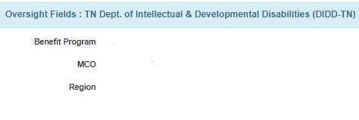
    - These fields are brought into the system via the API feed.
  - Review Advanced Directives for your individual are correct
    - Click Edit to enter data to the fields. You can add supporting documents for any options listed that you have the information for. Please follow the DIDD naming standards.
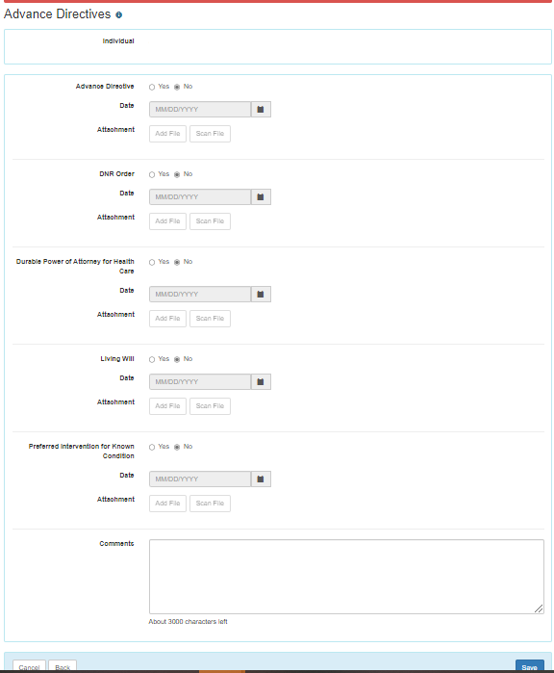
    - Click Save when finished.
  - Verify all information you have on the person.
    - See the screen shot below of available tabs on the person record.
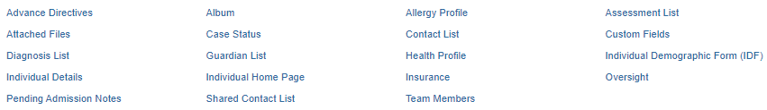
    - NOTE: Some items are completed in the Case Management account. E.g. Insurance

Personal Focus Worksheet
The decision has been made to use the Personal Focus Worksheet (PFW). The Public ICFs will use the Personal Focus Worksheet to feed data to the ICFs Person Centered Support Plan.
1/13/2023: A subsequent decision has been made to not require the PFW when 1915c and KBB Case Management goes live.

Reason: The development changes requested to merge certain PFW questions into the About Me section of the PCSP will not be ready for March 1, 2023.

The Person-Centered Support Plan

ISCs and Case Managers will need to switch to the Oversight account to complete the Person-Centered Support Plan
If you are searching for a plan that has already been created, click Search:
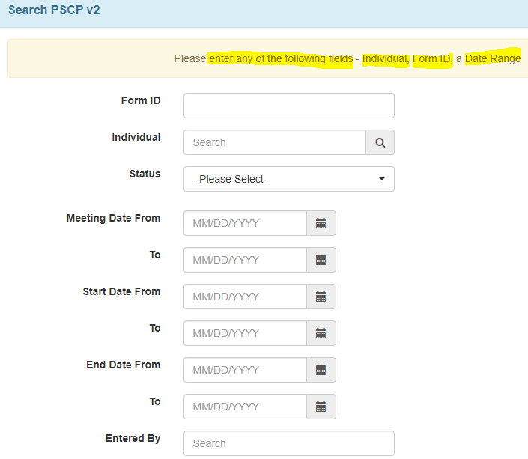
Enter the individual’s name in the Individual Search field. As you type the name, the system will display a list of possible choices. Select the individual from the list shown. If you see multiple instances of your individual, select the one with DIDD-TN behind the name.
NOTE: Please reach out to your regional plans reviewer if you are unable to locate a person in Therap.
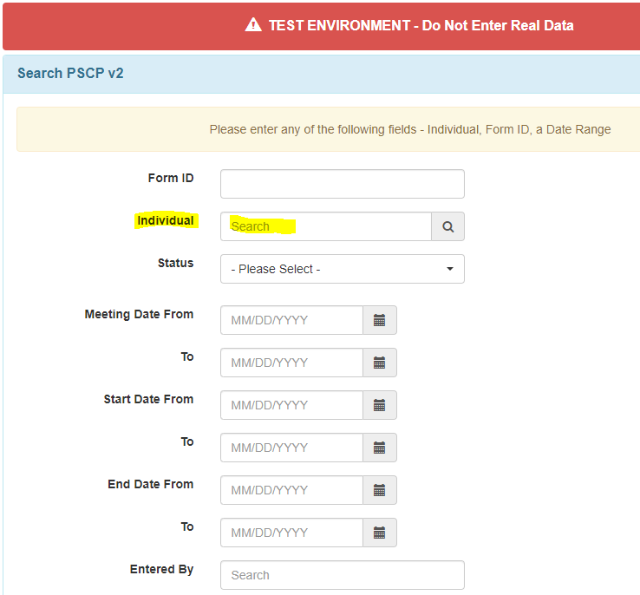
Scroll to the bottom of the page, click Search.
Start a plan by scrolling down on the dashboard to locate the Individual Plans section. Depending on your level of access you could see different options under each header.
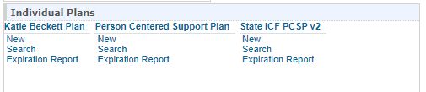
Click New below the plan type you will be creating.
- 1915c individuals will use the Person-Centered Support Plan.
- Katie Beckett Individuals will use the Katie Beckett Plan and will follow DIDD specific guidance.
- Public ICF’s will use the State ICF PCSP v2 template.
- Other plan types could be added in the future.
The first portion of the PCSP will be pulled into the form from the person’s demographic information form.
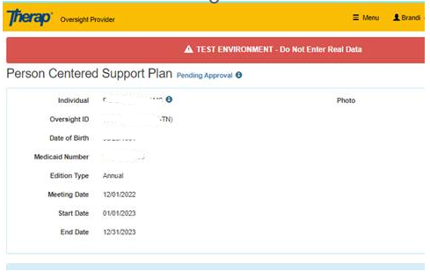
Select the Edition Type from the drop down.
- Initially it will be an Annual plan in Therap
- When the plan is amended, change the Edition Type to Amended.
- REMINDER: To amend an approved plan, you have to first do a Change Form. If not, you will get this message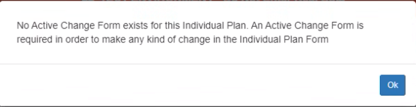
- Enter the meeting date
- Enter the plan start date
- Enter the plan end date
- Click Save and Continue Editing. 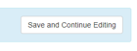
NOTE: to move around the form you can use the Jump to button.  It provides a list of the sections that are a part of the PCSP. The “?” button provides some help along the way.
When filling out the PCSP, when each section is complete, you should go up to the top of the document and click on the “Save and Continue Editing” button. When this is done, there will be green message printed on the top of the form which says it has been saved.
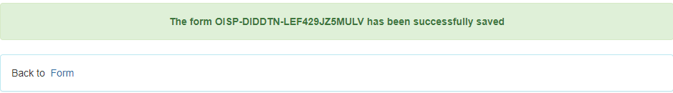
About Me:
NOTE: 1/13/2023: A decision has been made to not require the Personal Focus Worksheet (PFW) and Charting the LifeCourse (CtLC) Vision Tool when Case Management goes live that would import answers into the About Me section. Users are not required to complete those modules during plan development.

The About Me section is equivalent to the Home and Day section of the traditional DIDD PCSP with prompts to enter person-centered information about what’s important to/important for the person. The Personal Outcome Measure indicators are imbedded into the plan questions.

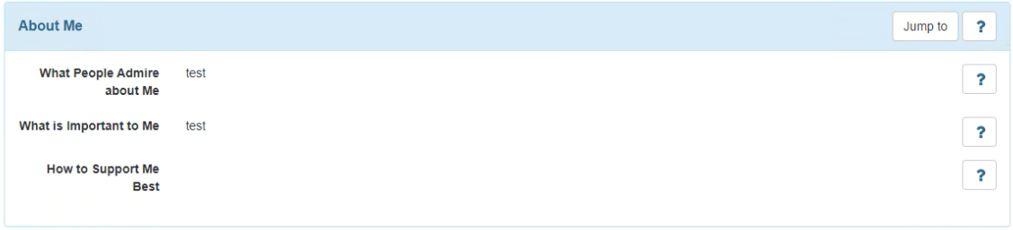
Participant: It is optional to complete this section as meeting attendees will be officially recorded on the standard DIDD PCSP signature sheet.
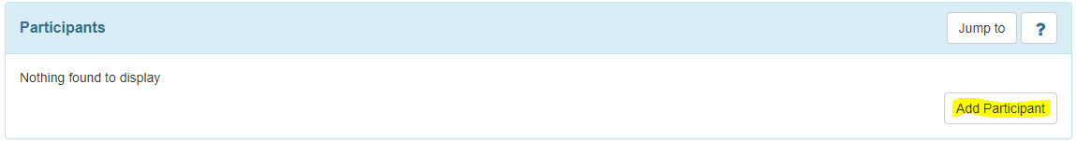

Once added the participant will show on the PCSP similar to this screen.

Signature Sheet: Not used at this time. Users will upload the DIDD (non-Therap) signature sheet into the Documents Checklist to record PCSP meeting attendees.
Legal Decision Maker: The legal decision maker is initially created in the Contact List first in the IDF. The user then checks Legal Decision Maker button under Team Member, so the person appears in the PCSP. Documents can be added to contact record and team member record.
If a contact is indicated as a Conservator, legal documents can be uploaded to the contact record. Please follow the DIDD Guidance for naming the document.

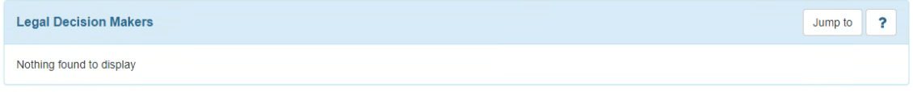
Risks: The Risk categories from the DIDD Risk Issues Identification Tool (RIIT) and Risk Analysis Planning Tool (RAPT) were imported into the Risk section of the Therap PCSP. Therefore, those documents are no longer required. When you add a risk, select “Risk Type” from the dropdown menu. If nothing matches, select “Other” and complete the comment section. Under “Support Documents,” you can add additional forms supporting the risk.
Professional Services: This section is optional and is subject to change. This is where you will enter the doctor’s information.
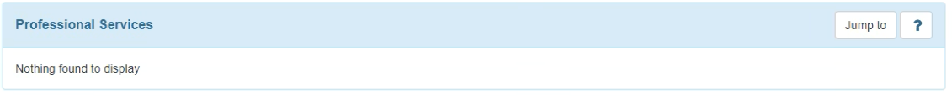
Nursing: Enter the information and answer the questions as best as you can. If it does not apply to the person, then leave it blank. If you don’t have the information and you know that the provider has the information, put “Follow up with provider.”
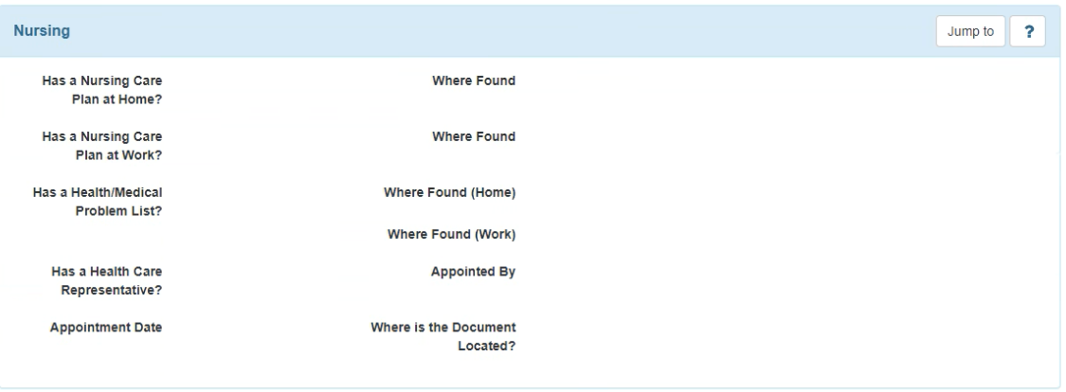
Services and Supports: This is an important section, formerly known as the Section C. Complete it as thoroughly as possible to request each service justified in the plan.
- Service dates must break during fiscal (6/30) and calendar year (12/31) and must be calculated within each break. There is a maximum of 75 individual service line limit in this section.
- The service request type may be documented in the Notes section of the service line item. (Ex: Add service, delete service, increase units, decrease units).
- Do not attach any documentation to the individual service request. All supporting documentation needed to be submitted with the plan to Plans Review must be uploaded in the Documents Checklist.
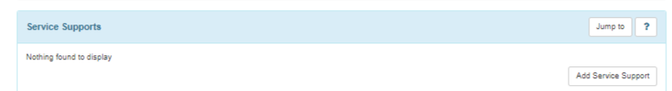

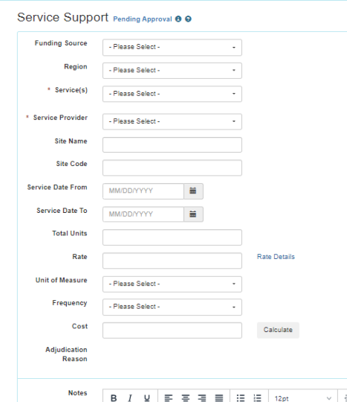
Everyone supported in services is associated with a funding source and budget within Therap. Therap will calculate the total cost of services when the services are entered on the Service Support form. Service support will calculate total cost of services based on what the ISC/CM enters on the Service Support forms. (i.e. if residential is entered for the entire plan year, the cost for the entire date range will be displayed.)

Natural Supports: Complete this section with the information you have.
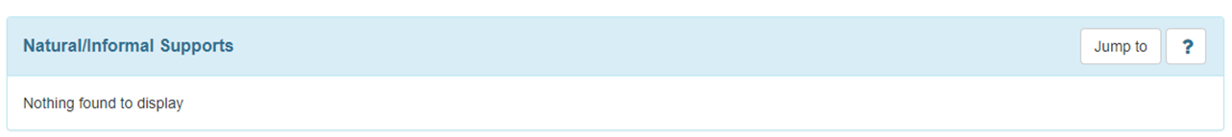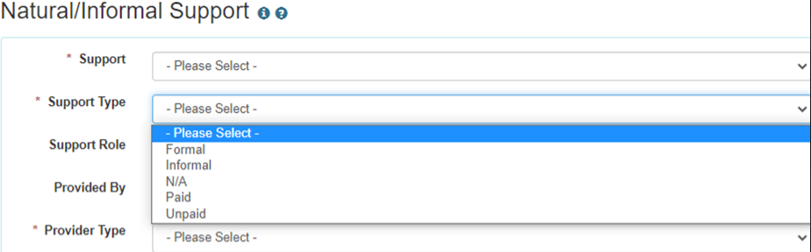
Use Informal for Support Type.
Restrictions: If there are no restrictions, please select No from the dropdown. If there are restrictions, please select Yes from the dropdown and click the Add Restriction button.
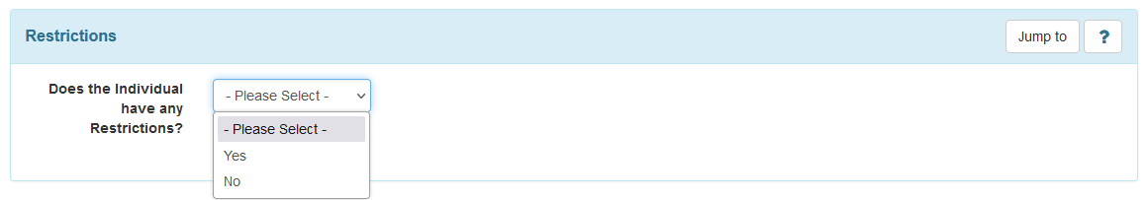
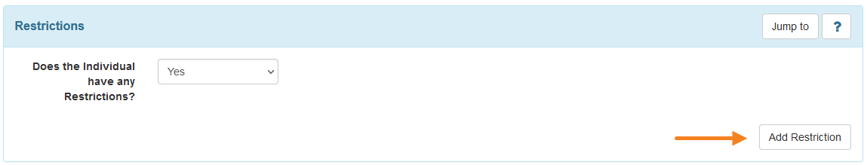
Complete the details of the restriction and press Continue to save the restriction to the plan.
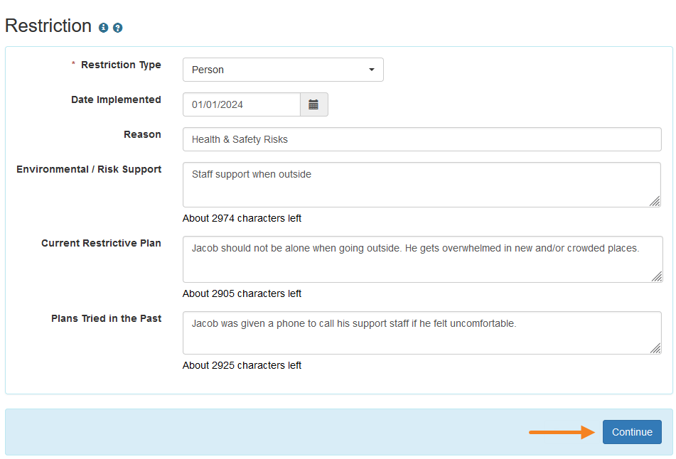
Action Plans: Complete this section as it is structured. This section replaces the Action Plan in the traditional PCSP. It can accommodate as many Actions Steps needed to support the person’s outcomes. There is an option to link to the Therap ISP Program in the PCSP.
Discussion Records: Not used at this time.
Document Checklist: This is the section where all attachments to the PCSP will be added. Please upload supporting documents in this section of the plan. Do not attach documents to actual service line items in the Therap Supports and Services section.

If additional documents need to be added for a category not listed, use the “Other” option and include information about the document.

The Questionnaire

The questionnaire is a requirement from TennCare. The data captured in this area is specifically to be able to report to TennCare.
The questionnaire is broken into several sections. When you click on a section header, on the left, the right-hand side will show the associated questions.
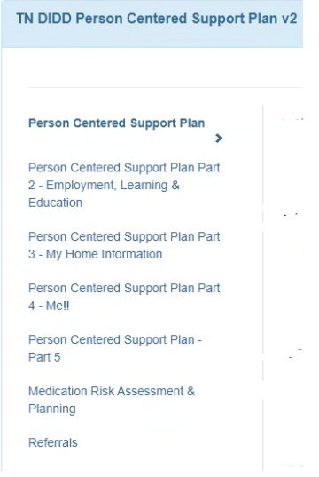 | 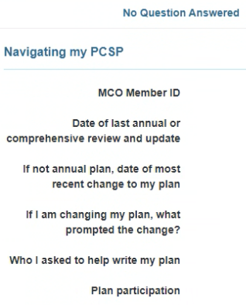
Throughout the questionnaire, answer the questions that you can (what you have information for); if you don’t have the answer leave it blank.
- Navigating My PCSP- This section is about the annual update, and who the person wanted included in the creation of the plan.
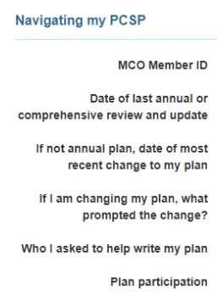
- My Communication Style- This section focuses on the communication style of the person.
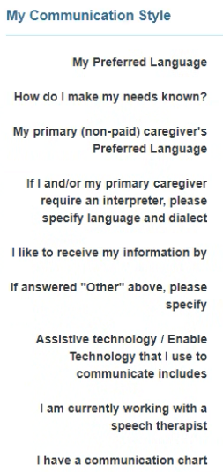
- My LTSS Information – This section is all about the cost cap, annual cost of services, etc. Note that there are questions in this section around education of Abuse, Neglect, and Exploitation (ANE), and the person’s concerns around ANE. It’s important to answer these questions because this is something that we are looking at from a systemic level.
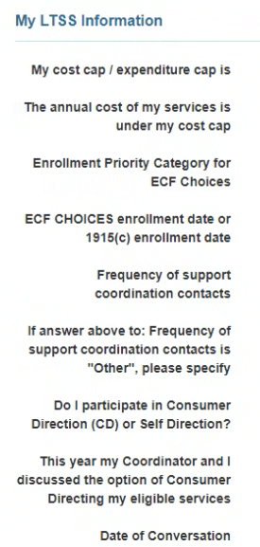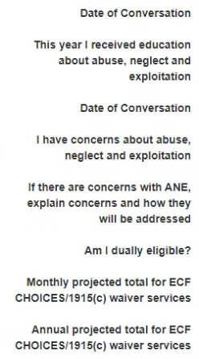
- My Decision Making and Rights- This is important information. If there are questions that you
don’t have answers for, leave blank and enter the information as you receive them. ISC/CMs cannot provide legal consultation, however if the person requests information on Advanced Directives – users may forward the person to TennCare’s website for information and templates with general information.
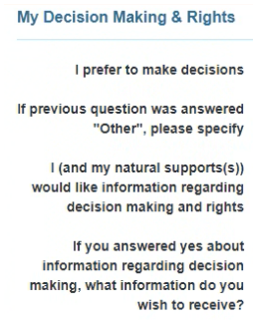 | 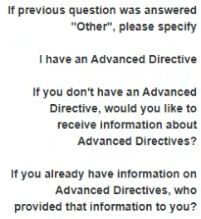 | 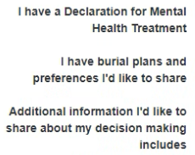

- My Community Activities – Complete this section fully.
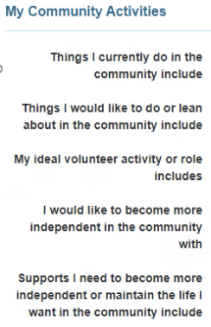

- My Employment Information and Interests- This starts the PCSP Questionnaire Part 2. If there are questions that you don’t have answers for, leave blank and enter the information as you receive them.
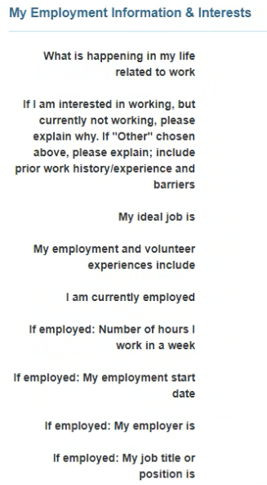

- Home – this starts Part 3 of the PCSP Questionnaire – This section is about access and concerns that the person may have around housing. If there are questions that you don’t have answers for, leave blank and enter the information as you receive them.
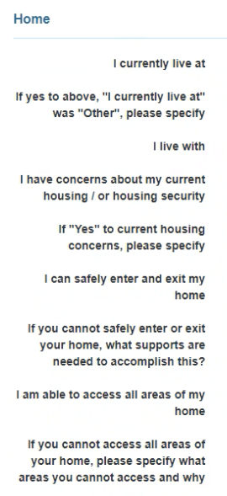
- Home Modifications -There are 2 questions in this section. Answer them. If there are questions that you don’t have answers for, leave blank and enter the information as you receive them.
- HCBS Setting Rule If there are multiple restrictions, upload a document in the Document Checklist section. If there are questions that you don’t have answers for, leave blank and enter the information as you receive them.
- Me Section starts Section 4 of the PCSP Questionnaire: My Meal and Food Preferences. The primary focus of this section is around mealtime. ISC/CM should provide information around foods the person likes/dislikes, any mealtime guidance, a note can be entered for any needed clarifications.
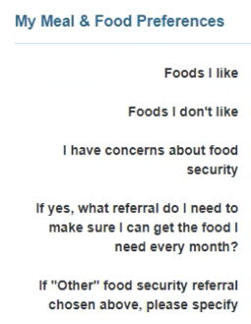 | 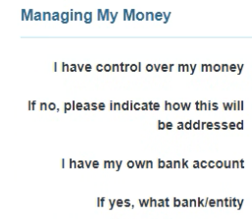
- Managing My Money – This section is all about money. If there are questions that you don’t have answers for, leave blank and enter the information as you receive them.
- My Physical Health – This is a lengthy section in terms of questions. Just remember that this section is basically replacing the “medical section” from the old plan format. If there are questions that you don’t have answers for, leave blank and enter the information as you receive them.
- Section 5 of PCSP Questionnaire starts here. My Natural Disaster Preparedness Plan – Leave blank because this is not something we do on the 1915c side. Providers are required to have emergency plans and that’s what is followed.
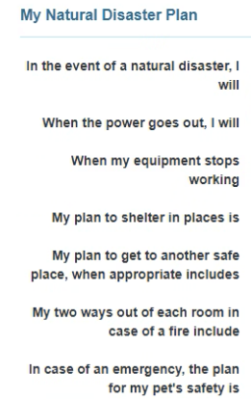
- Medication Risk Assessment and Planning – The information is primarily managed by the provider. The provider may provide this information during the planning meeting or submit it when they provide input for the draft plan. Following the annual meeting, refer to the Provider’s Health Tracking module for the most up-to-date information.
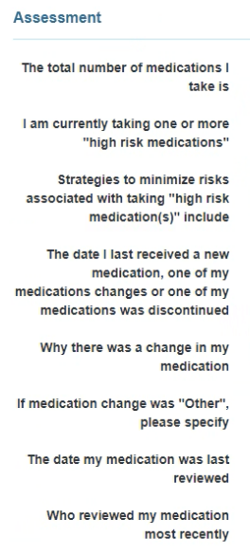
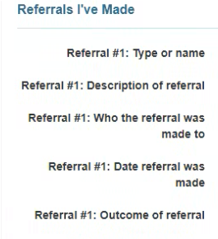
- Referrals – The completion of this section is optional. You can complete this section based on referrals submitted as a part of the annual plan if you choose to do so. If there are no referrals, leave it blank. You can enter up to five referrals.

Submitting the Plan

Sharing the Plan:
Providers are unable to view plans in draft status as they can only view the final approved plan. Sharing the draft with linked providers and sending it via SComm will allow the agency to use T-Notes to add their input on plan revisions.

To share the draft plan with providers, ISC/CMs must:
- Leave the Oversight account
- Switch to the provider account
- Select the To Do tab on the dashboard and click on the Worklist
- Search for the person’s draft plan
- Scroll to the bottom and select Edit to open the plan
- Scroll to the bottom and click “Save and Share with Linked Providers” to share the plan.

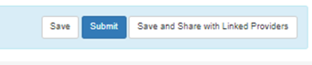

To attach a plan to an SComm, users may navigate back to the form and select the “Multiprovider SComm” button at the bottom of the draft plan.
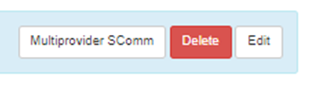
This opens the page for the ISC/CM to compose a new SComm. The users may enter recipient names who need to review the draft plan. Users will need to contact their administrators to review roles and privileges in order to send, receive, and view Multiprovider SComms.
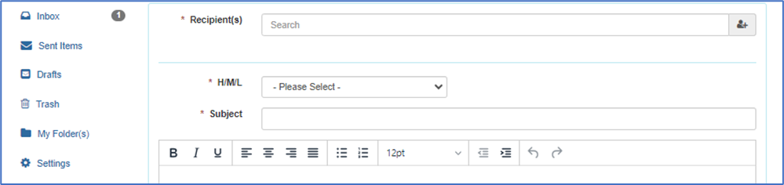

Notification when a plan is complete:
Completed PCSPs are sent to Plans Reviewers when the ISC/CM or designee clicks the Submit button.
Send an email to the regional email box when you have submitted your plan in the Therap system. Please include the Form ID for the plan so that the Plans Reviewers can find the correct individual and plan to review.
- East - dd_etro.plans@tn.gov
- Middle - mtro.plansreview@tn.gov
- West - plans.service@tn.gov
Plans Reviewers will review the plans and approve them in Therap after they have reviewed everything.
- When a plan is approved, the ISC/CM will see a button to Acknowledge the Plan in Therap.
- Every provider associated with the plan, who has a Therap account, will also see a button to Acknowledge the Plan.
- The notification will show on the provider and ISC or CM dashboard.
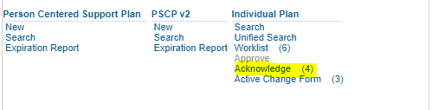

Return for Clarification
When a PCSP is submitted to DIDD, the ISC/CM will also send an email to the regional mailbox to alert the Plans Reviewers that a plan is ready for processing which should include the Therap Form ID of the plan.
- East – dd_etro.plans@tn.gov
- Middle – mtro.plansreview@tn.gov
- West – plans.service@tn.gov
If for any reason the Plans Reviewers have questions or need clarification on what was submitted, the system allows the plan to be returned to the ISC/CM.
- If the Plans Reviewer has not clicked on Edit on a submitted plan, the ISC/CM may upload any missing information.
- If the Plans Reviewer has clicked Edit on a submitted plan, the ISC/CM can reply to the RFC email with the required missing document. The Plans Reviewer will upload the new submitted documents.
- If there is other missing information that the ISC/CM must update, the plan will need to be updated by the ISC/CM. The Plans Reviewer may return the plan to the ISC/CM as a withdrawal so corrections may be made.
Plans Reviewers will click the return button at the bottom of the screen. Plans Reviewers will also reply to the email that was sent to inform the ISC/CM that the submitted plan was returned.
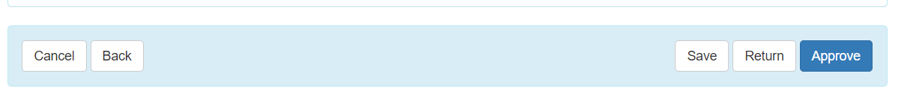
When the Plans Reviewers return the plan, there will be a message confirming the plan was returned.
The information button on the plan will indicate all the information about the plan including that the plan was returned.
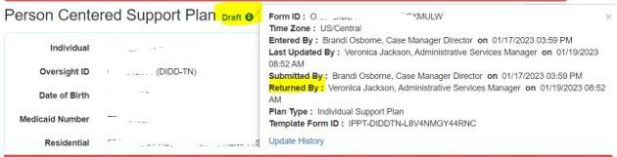
From the ISC/CM’s dashboard, the ISC/CM will click the To-Do tab, then select Worklist from the modules list.
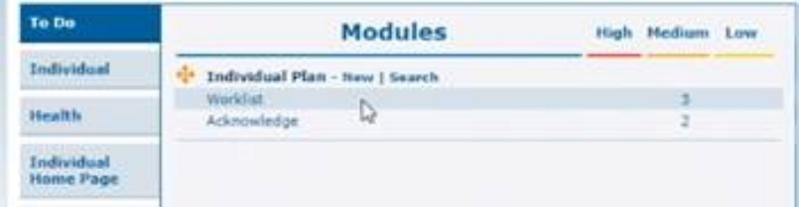
The Work List will open the Individual Plan List and show the PCSPs that are in process.
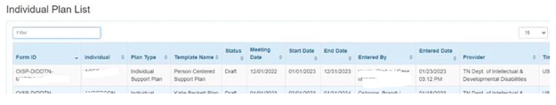
The ISC/CM will select the person’s PCPS that was returned from the Plans Reviewers.
The returned plan will appear in Draft status.
The ISC/CM will select Edit at the bottom of the screen to open the plan and make the requested corrections.
The ISC/CM will Submit the final updated plan to the Plans Reviewers.
NOTE: If the ISC/CM has access to the Oversight account, the ISC/CM can go through the multiple steps to access the plan from the oversight account, however, the worklist takes the ISC/CM directly to the Individual’s Plan.
The ISC/CM will also send an email to the Plans Reviewers mailbox to alert the Plans Reviewers that the corrected/updated plan has been sent again for processing.
- East – dd_etro.plans@tn.gov
- Middle – mtro.plansreview@tn.gov
- West – plans.service@tn.gov
The ISC/CM should reply to the same email that alerted him/her that the plan was returned.
Once the plan is approved, the Return button will not be available to the Plans Reviewers. The ISC/CM will need to use the change form to send in amendments/changes to the plan.
Plans Reviewers will continue to notify the ISC/CM/Provider via Outlook email of the disposition (approval/denial) of the service plan.

Change Process

NOTE: A change form must be started when a plan needs to be amended. This allows the ISC/CM to be able to edit the Plan. Without the change form, you cannot edit an approved plan. Therap will display the following error message.

Amendment/Change Form:
It is important to note that the number of amendments that are submitted to DIDD by far greatly exceed the number of annual plans submitted. Nearly every plan is amended at least once during the plan year on average, and many plans are amended several times in a year’s time. The number probably is at least double that of annual plans.
- The “Change Date” on the Change Form is synonymous with the “Amended Date” in current ISP parlance Please change the status on the PCSP to Amended when an amendment is created.
- The “Edition Type” on the PCSP form must be changed to “Amended” as a first step in updating the plan after the Change Form is activated.
- A “Change Form(s)” section is added to the bottom of the PCSP when a form is created.
The ISC/CM should check the appropriate box in “Document(s) being changed, added or discontinued,” to indicate where the change is being made.
- Always select “Individual Plan” when creating a change form
The “Reason for Change” drop down will have the following items for the ISC/CM to choose from when a change form is created. Details of the changes to the PCSP must be on the PCSP and not on the Change Form. A short summary can be added in “List specific change(s).”
Amendment
DIDD Correction
Emergency Authorization
Information Only (this would not go to the Plans Reviewer group for processing)
Reconsiderations
TennCare Appeals Directive
TennCare COB
Transitions
Other

ISC/CM will use Information Only, Amendment, Transitions, or Other all other options are for Plans Reviewers use only.
If Other is selected, the user will need to complete the Other Reason field.
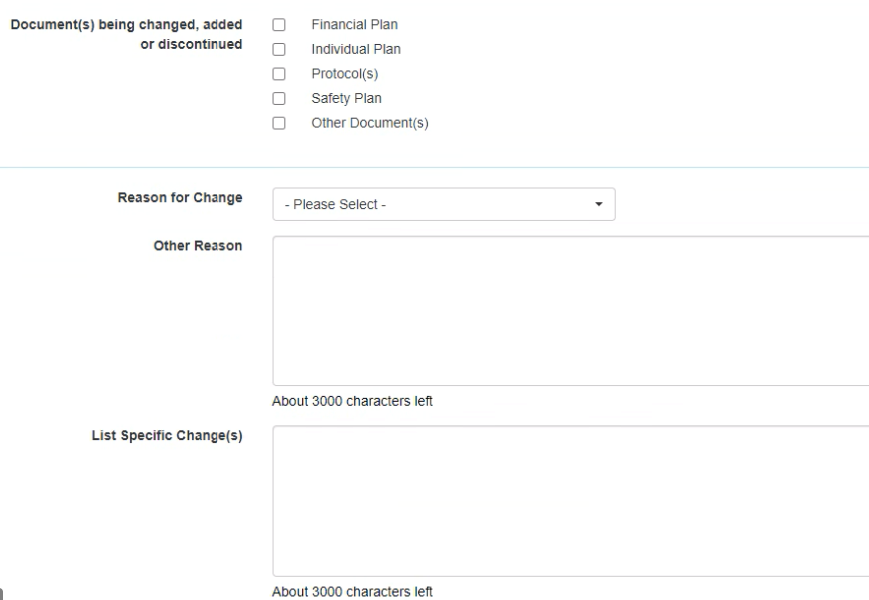
The ISC/CM can summarize specific changes in “List Specific Change(s) field and the section of the Plan that was changed in “Where is the Change Documented?” field of the change form. This is not meant to be the documented change.

- Acknowledgement List: ISC/CMs may ignore this section as it is not a requirement for processing DIDD amendments.
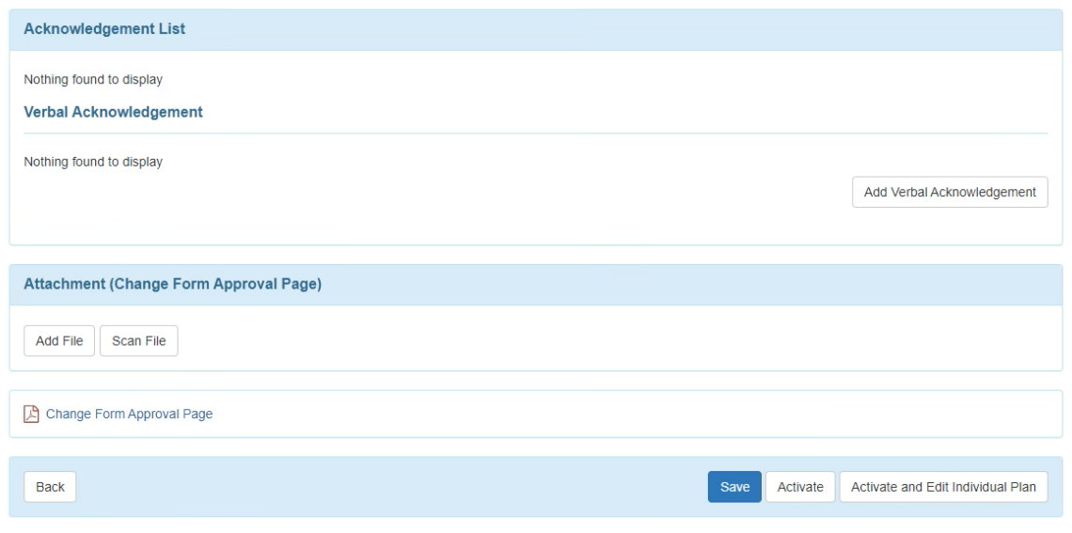
- Users can print the change form if a hard copy is needed in the home.
- Once the change form is completed the user will select Activate the Change form.
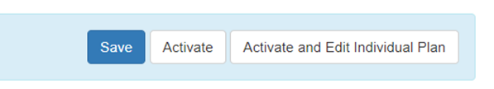
- The “Edition Type” on the PCSP form must be changed to “Amended” as a first step in updating the plan after the Change Form is activated.

Submitting a Change Form
To amend a plan, Therap requires you to open a Change Form.
The change form is needed to allow the PCSP to be edited. If one is not completed and the user tries to modify the approved plan, this message will be displayed.
- Click OK,
- Create the change form.
Do not type all the changes on the change form. When a change form is completed, the ISC/CM should indicate on the form the type of change.
The Type of Change drop down has been updated to give you the choices shown below. If none of these apply, select Other, then add a brief description.
The actual changes to the PCSP must be on the PCSP and not on the Change Form.
Amendment
DIDD Correction
Emergency Authorization
Information Only (this would not go to the Plans Reviewer group for processing)
Reconsiderations
TennCare Appeals Directive
TennCare COB
Transitions
Other

If the ISC/CM added Information Only to the Change Form, then that would indicate to the ISC/CM that they could use the UPDATE button to close the change form. It would not go to the Plans Reviewers for processing.
If the ISC/CM chose another “reason for Change” It would require the ISC/CM to use the UPDATE WITHOUT CLOSING THE CHANGE FORM button and it would go to the Plans Reviewers for processing.
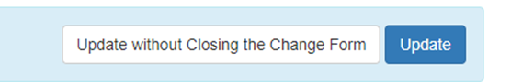
The ISC/CM that is submitting the change form must also send an email to the Plans Reviewer’s regional mailbox to indicate that a change has been made to the person’s plan. The ISC/CM should not send a pdf copy of the plan. The ISC/CM may must send the form ID in the email. You can locate the form ID at the top of the plan by clicking the next to the status of the plan. Highlight the Form ID: and the number that follows, then right click, select Copy, then paste this into your email.


Creating a New Plan from an Existing Plan

If the user needs to create a new plan for the new PCSP year from an existing plan, they can use the COPY feature. This will import any historical data from the original plan. To copy a plan:
- Go to the individual’s dashboard
- Click on the plan tab
- Open the existing approved plan
- Scroll to the bottom and select COPY to create the new plan from the old plan.

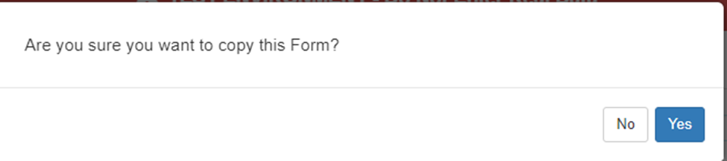
Click Yes to continue. The system will show you that it is a new plan, and a copy of the previous plan. The user will need to put in the correct dates at the top of the screen. Click Save and Continue Editing to save the copy created.

If you didn’t mean to copy the plan, scroll to the bottom of the page and use the cancel button to not save the copy.
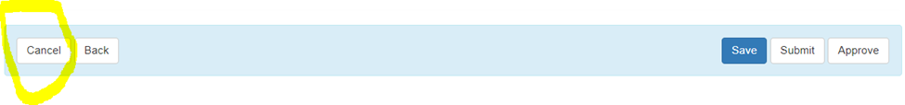
When you click cancel, you will see this pop up screen
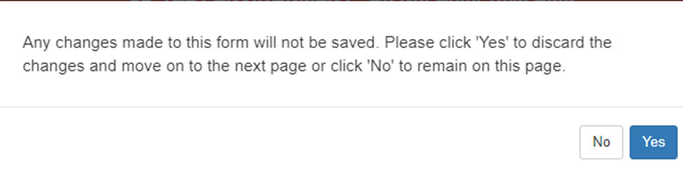
Click Yes to continue. The copied plan will not be saved.

How to Assign CM Provider
At the Oversight dashboard, click on Assign CM Provider under Multi-Provider Individual section

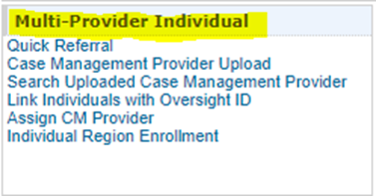

Click on Assign CM Provider (second to last option). The system returns this screen.

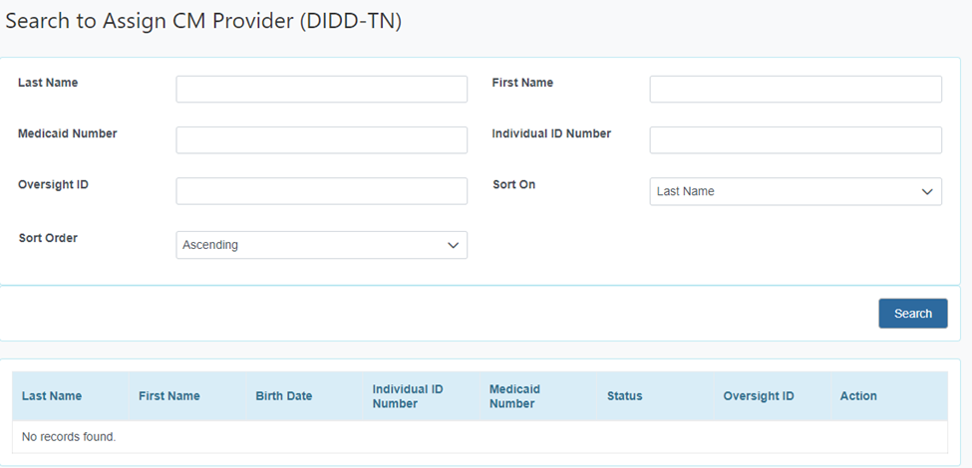

Enter the last name and first name of the person you want to assign, then click the Search button at the bottom of the screen. If the person is found, the information will be displayed at the bottom of the screen. Scroll over to the last column to see the action button, if it is not visible.
Click Assign
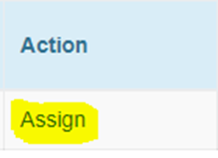

The system returns this screen.
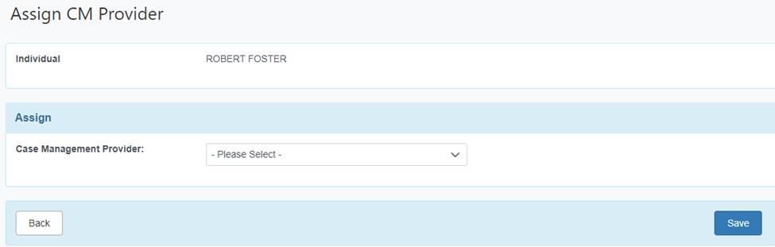
Click the drop down next to Case Management Provider in the Assign box to select the provider.
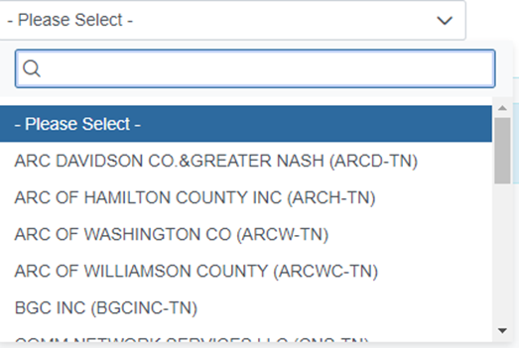

In the filter box with the magnifying glass, begin typing the provider’s name. The system will filter as you type.
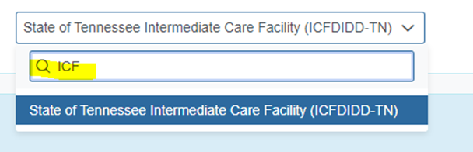

Click on the provider’s name when you see it displayed.
Then Click the Save Button at the bottom
This will assign the person’s Case Management Provider. This process needs to be done for
- ISC accounts (17 accounts)
- DIDD Case Management account (CMDIDD-TN)
- Public ICF account (ICFDIDD-TN.)

Creating a DIDD Caseload by Region
What Role should do this?
- It’s available on the Administrator, Operations role for the ICFs. Login instructions start at Step 1.
- If you have a DIDD Supervisor account (DDxxxxx_cms), you should have this ability. Login instructions start at Step 2.

Preliminary steps that need to have been done first
- Quick Referral of individuals to the provider account (CMDIDD-TN or ICFDIDD-TN)
- Assign CM Provider of individuals to the CMDIDD-TN or ICFDIDD-TN account.

Login Instructions:
- If your role is Administrator, Operations for an ICF
- Log into the Oversight Provider Code (DIDD-TN)
- Click Switch Provider to go to the ICFDIDD-TN Account
- On the Switch provider screen, locate the filter box and type ICF if going to the ICFDIDD-TN account, or type CMD if going to the CMDIDD-TN account
- When you see your account click on the name to continue to the selected provider account.
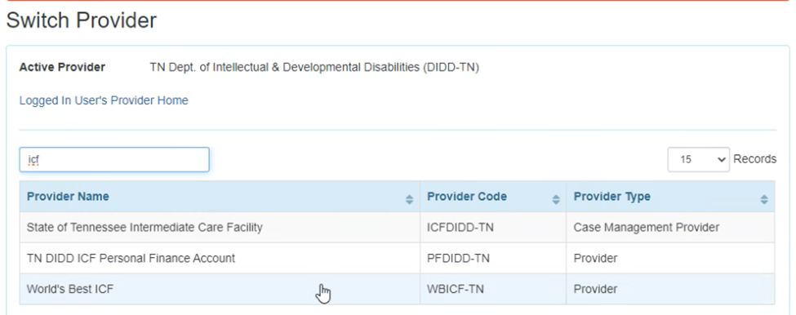

- If your role is DIDD Case Manager or a QIDP, log in with your DDxxxxx_cms account
Once at the Dashboard for your account follow the instructions below.
- Click on the Admin on the left-hand side of the screen. The center options change with each tab.
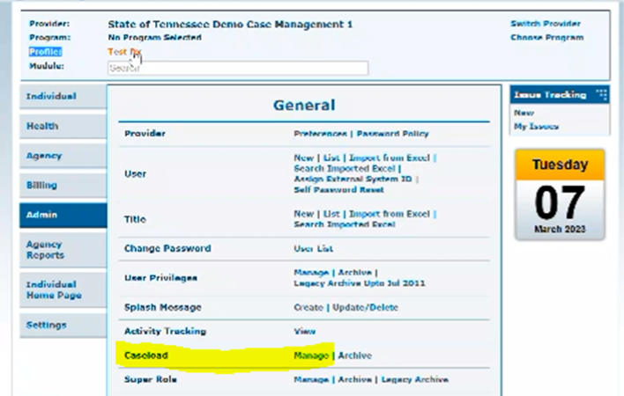
- Under Caseload, click Manage to open the screen so you can create a caseload
- You will see a list of caseloads already in the system.
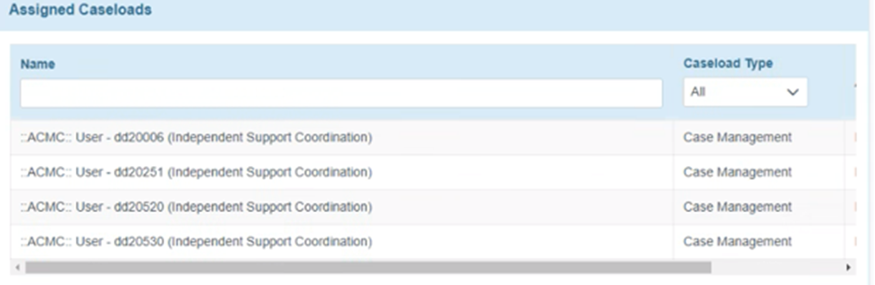
If you see the gray bar, scroll it over to see additional columns.

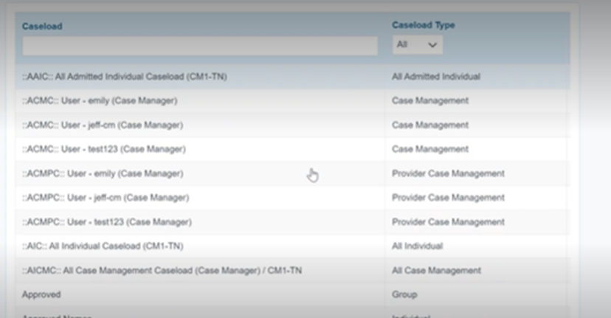
- State oversight caseloads will have the caseload type of Case Management (ACMC)
- Provider Case Management (ACMPC) indicates the internal caseload

- At the bottom of the screen, select Create New Caseload
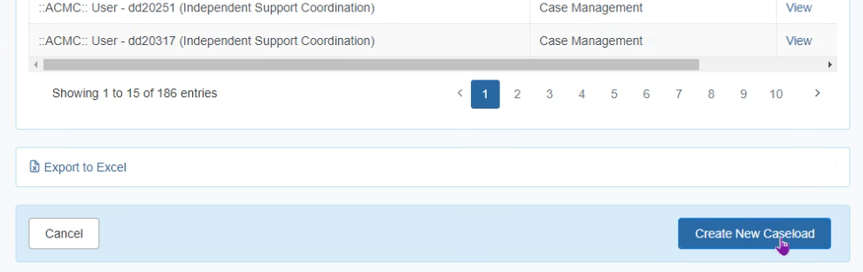

- Select Case Manager Group. 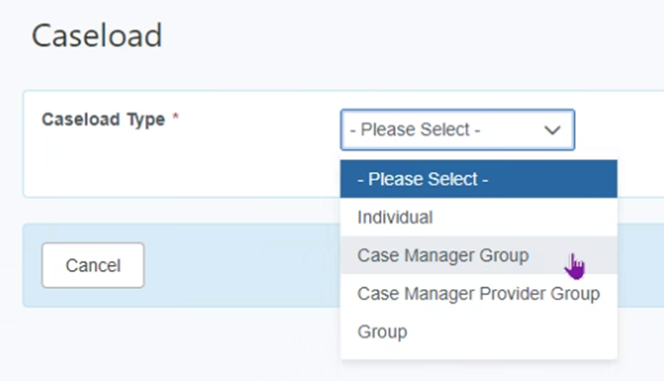
- On the next page, insert a name for your caseload
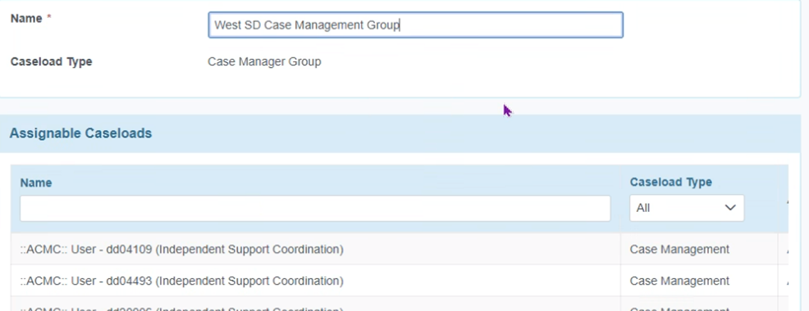
- In the name field, give it the name of the Regions. For example: East Oversight
- Add the caseloads of each Case Manager or each QIDP in the region to the newly created group by clicking “Add.” You may need to scroll right to see the “Add” buttons. Repeat this step for each caseload that you want on the group caseload.
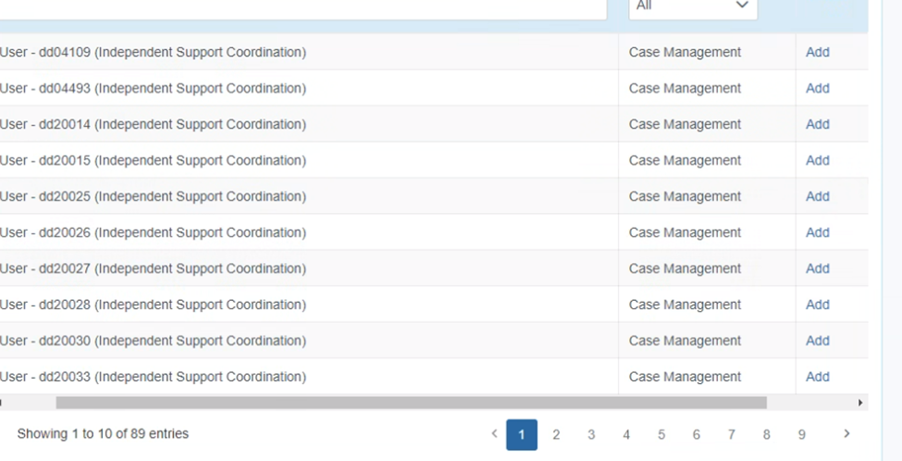
- Click Save at the bottom of the screen.
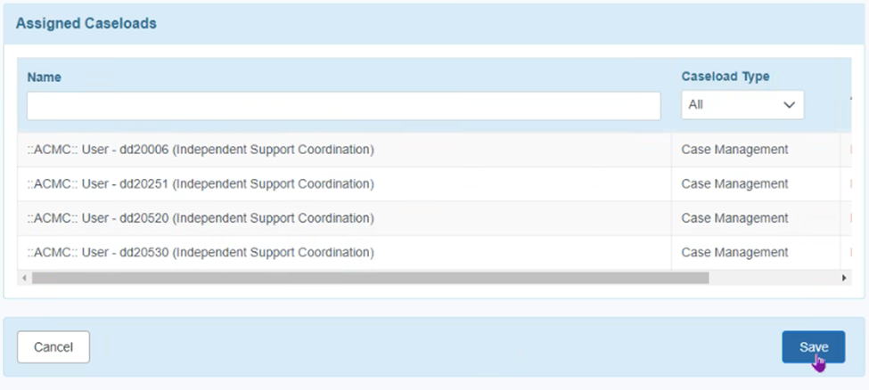
- This new caseload group should be added to the Oversight & Provider Profile of each Case Manager or QIDP. This gives the person access to the caseloads of the people added to this caseload group.
- Each Case Manager or QIDP should have an individual caseload added to his/her Initial Profile. The individual case load will have the users RACF ID in the caseload name. It should only have those individuals that the Case Manager or QIDP is directly responsible for.
- When a new case manager is hired, the person’s caseload needs to be added to the group caseload.
- For the new person’s caseload to be added to a group, the person must have at least one individual assigned before the caseload can be created.
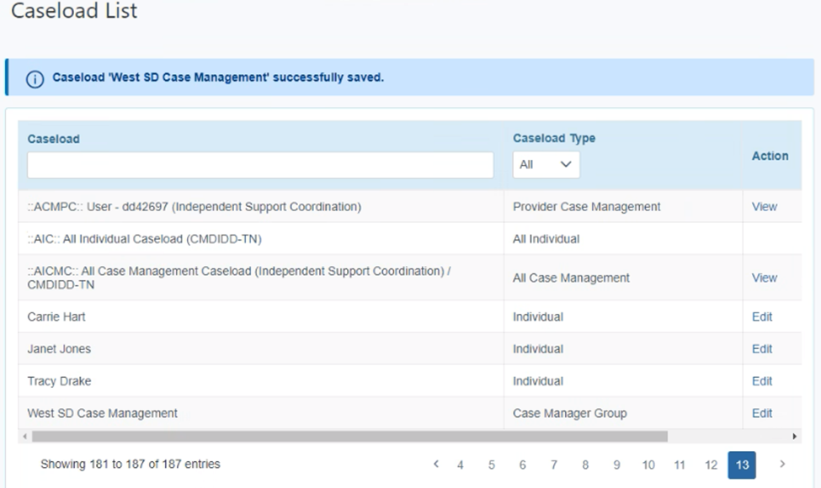

- In this example, you can see the Case Manager Group called “West SD Case Management” in the list above.

To manage the group list, from the above screen, select Edit in the Action column. This will allow you to add or remove individual caseloads from the group. Changes are automatically shared to anyone who has this caseload on a profile.

Appendix

Core Fields
Certain Individual Demographic Data fields are overwritten by the API that gets information from TennCare and updates Therap.
- The API will update current person demographic records in Therap on a daily basis with changes sent from TennCare. The fields to be updated are considered the Core IDF Fields. See attached document for a complete list.
  - Those fields include:
    - Gender
    - First Name
    - Last Name
    - Middle Name
    - Birthdate
    - SSN
    - Medicaid Number
    - Email
    - Phone Number
    - Race
    - Residential Address (this translates to multiple fields such as street, city, state, zip for each time there is an address fields)
    - Primary Phone
    - Additional Phone
    - Residential County State
    - Residential County
    - Mailing Address (see comment at Residential Address)
    - Benefit Program
    - MCO
    - Region
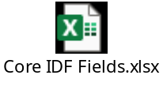

Therap Roles: Supervisors Guide
A copy of the Supervisors guide to Therap roles can be found on the Therap TN Support Page
Therap for Tennessee Developmental Disability Service Providers (therapservices.net)
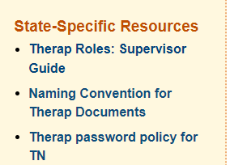

How to request Access to Therap
After reviewing the supervisors guide, the supervisor will complete the Form Stack request form https://stateoftennessee.formstack.com/forms/therap_account_request
DIDD Case Managers will request provider account CMDIDD-TN
Other DIDD users will request DIDD-TN

DIDD Naming Convention for Therap Documents:
DIDD’s Naming Convention Document can be found on Therap’s TN Support page under State-Specific Resources.


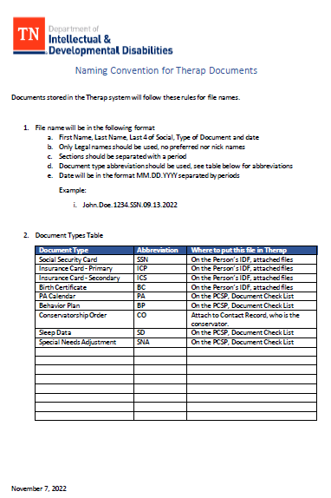

Changing an Individual’s Support Coordinator
The process for changing an individual’s support coordinator requires the following:
- ISC transitions will be handled by the DIDD Transitions Unit in each region. The DIDD Operations Group will serve as consultants to the process.
- A Quick Referral of the person to the new ISC Agency is the first step in the process.
- Then the Transition user will Assign CM Provider to the referred individual
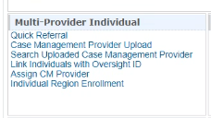
- The current ISC must discharge the individual in their account.
- ISC Agency or DIDD Case Manager Director or designee will assign an individual to a case manager.
Therap guidance document. Assign Case Manager to Individual (therapservices.net)

Therap support page: Assign, Remove, and Upload Case Management Provider (therapservices.net) for more detailed steps.

Discharge an Individual
DIDD will discharge an individual from service in Therap
For an individual at a Provider or ISC Agency, users with the IDF Admin role or the Individual Admit/Discharge caseload based role can discharge individuals from the agency. Please review the Therap support page for additional information.
Discharge Individuals (therapservices.net)

ISC Provider Codes

- DIDD Case Manager’s provider code is CMDIDD-TN
- Each ISC has its own provider code for its Therap account.

Number |  | ISC Agency Name | ISC Agency Therap Provider Code
1 |  | ARC of Hamilton County, EAST region | ARCH-TN
2 |  | ARC of Washington County, EAST region | ARCW-TN
3 |  | ARC of Williamson County, MIDDLE region | ARCWC-TN
4 |  | Building Greater Communities, MIDDLE region | BCGINC-TN
5 |  | Community Development Center, MIDDLE region | CDC-TN
6 |  | Community Network Services, EAST region | CNS-TN
7 |  | Compass Coordination, WEST and MIDDLE regions | COCO-TN
8 |  | Direct Access Coordination, MIDDLE region | DACINC-TN
9 |  | Engstrom Services/ Community Connections, WEST, MIDDLE and EAST regions | ESINC-TN
10 |  | Miracles Network Agency, WEST region | MNA-TN
11 |  | Neighborhood Network, WEST and MIDDLE regions | NNI-TN
12 |  | Porter Consulting Group, WEST region
13 |  | Quality Care Support, WEST region | QCSUPC-TN
14 |  | Quality Support Coordination, WEST region | QSCOTN-TN
 | 15 | Tennessee DIDD Case Management | CMDIDD-TN
16 |  | Tennessee Community Services Agency, WEST, MIDDLE and EAST regions | TNCSA-TN
17 |  | The ARC of Davidson County & Greater Nashville | ARCD-TN
18 |  | Vision Coordination, EAST region | VCSRVS-TN

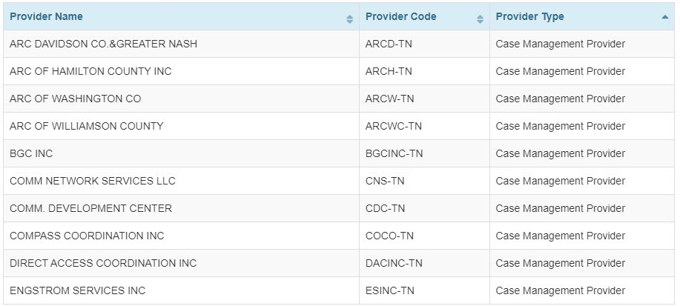
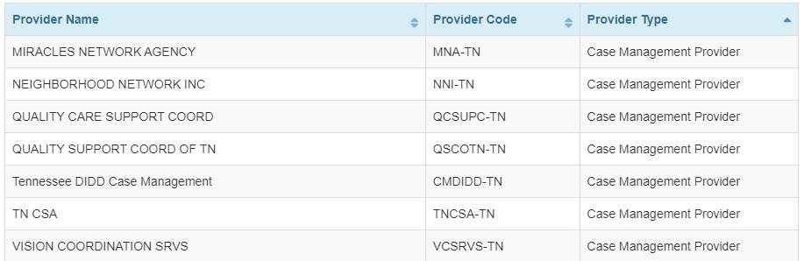

Acronyms and Abbreviations Definitions
Acronym / Abbreviation | Full Name | Definition
ANE | Abuse, Neglect and Exploitation
API | Application Programming Interface | This is the process that will bring data from TennCare to the Therap system.
AOD | Administrator On Duty | The person on call nights and weekends, that can authorize emergency services
Benefit Programs | Also referred to as funding sources, money source for individuals supported by DIDD.
CAC | Comprehensive Aggregate Cap | One of the waivers under the HBCS/1915c amendment
CM | Short for Case Manager | ISC agencies and DIDD have Case Managers that support individuals in the various Waivers or Benefit Programs.
COS | Circle of Support
CtLC | Charting the Life Course
DIDD | Department of Intellectual and Development Disabilities | DIDD supports individuals in the Home and Communication waivers such as CAC, SD, SW. DIDD also supports children in the Katie Beckett Program.
HCBS | Home and Community Based Services | CAC, SD and SW waivers fall into this category.
IDF | Individual Demographic Form
ISC | Independent Support Coordinator | An agency that assists with writing support plans for CAC and SW benefit program recipients
KB | Katie Beckett Program | Benefit program for children 18 and younger.
PCSP | Person-Centered Support Plan
PFW | Personal Focus Worksheet
PR | Plans Reviewer
SComm | Secure Communications | A module for users to exchange information within the Therap system
SD | Self Determination Waiver | One of the waiver programs under the HBCS/1915c amendments
SW | Statewide Waiver | One of the waiver programs under the HBCS/1915c amendments
Waivers | Benefit Programs | HCBS benefit programs that include SD, SW, and CAC under the 1915c grouping.

Frequently Asked Questions

Category | Questions | Answers
Activity Date | The admission date on our individuals is not correct, why is this so? | The API uses the activity date as the admission date. So what the user is saying is correct. The admission date is not really meant to be “used” for anything other than to show when the person was admitted into Therap. The Waiver Enrollment module will actually record eligibility start and end dates.
Case Notes | What happens during the approve process for Case Notes? | Case notes only have Save and Submit, there is no approve option in this workflow. Submitting the form is a way to change the status of the form indicating it is complete, while save indicates the form is still a draft.
CtLC | Who approves the Charting the LifeCourse forms? | A decision was made not to use CtLC forms. However, CtLC has a separate set of approvals that can be assigned as needed. DIDD does not require the Plans Reviewers to approve  these forms.
CtLC - Vision Tool | What is the difference between Save and Approve on the Vision Tool? | A decision was made not to user CtLC forms. Approving the form is a way to change the status of the form indicating it is complete, while save indicates the form is still a draft. The form can still be edited after approval by users with the CtLC edit privilege in their super role. Only CtLC forms that are approved can be linked to the PCSP and shared with linked providers.
CtLC - Vision Tool | In the Vision Tool under charting the life course. There are only options for two perspectives: individual supported and family. What if the individual does not express answers to these questions (whether non-verbal or in another method of communication) and there is no family to ask? Will there be an option to choose for the COS's perspective? | A decision was made not to user CtLC forms. So best practices take into account that those in a person's circle of support may be those who are interpreting the wants and desires of those who do not use words to communicate. From that perspective, they would use the Individual Life Domain Tool. If the person has family, they may use the one for families based on information the family members may share. We do not have an option specifically for COS because these tools are adapted from what the University of Missouri-Kansas City, LifeCourse Nexus has published. Therap is their technology partner and cannot create forms beyond what they have published to date.  The form is Optional. It is a third-party feature, and can't be modified by Therap.
Dashboard | As we get more functions in Therap, can the dashboard be customized so that sections (such as Individual Plans) can be moved to the top for PR staff? | The Dashboard is not customizable for a specific user at this time.
Diagnosis | How do I find Diagnosis to enter into the record in Therap? | Users can filter by "Intellectual Disabilities" to get a reduced list. The primary diagnosis box should be checked for the primary diagnosis, and it should be related to the reason the person is receiving services.
Diagnosis | We are unable to find all the diagnosis codes in the system. What should we do? We also see a pink box around what we enter. KB Diagnosis did not show up in the list. | The pink indicates there is non-standard data in the field. It is discouraged to manually add data vs using the drop down.  KB diagnosis words did not show up in ICD-10 list. Suggestion: reach out to physician for more info. It is important to enter the diagnosis that allowed the person to qualify for service. Diagnosis codes are important for billing. For 1915c, here are some diagnosis for ID.  Codes  • F70 Mild intellectual disabilities  • F71 Moderate intellectual disabilities  • F72 Severe intellectual disabilities  • F73 Profound intellectual disabilities  • F79 Unspecified intellectual disabilities
Diagnosis | How important is it to have the correct ICD-10 code? How is the code being used? Currently, diagnoses listed in the ISP are used to inform supporters on current conditions, how those conditions may present/affect the person, and how the person is supported to treat them. The significance and expectations around using a specific ICD code are unclear. | A person's primary diagnosis should match what was entered on the PAE to qualify the person for the benefit program. Additional diagnosis can be selected and recorded as needed.
IDF | Specifically, which fields in the IDF are overwritten by the daily TennCare feed?  • Of the two blocks of address fields (residence and mailing addresses), which ones are overwritten or not overwritten?  • Other than address fields, which other fields are overwritten? | There are 33 fields that are considered core fields that will get overwritten when an update is received from TennCare.
IDF | How do I search for my person in Therap? Which person do I select? | Users should navigate to the Oversight account via the Oversight & Provider Profile. Begin typing the person's name in the search field. If multiple instances of the person show up, you will select the person associated to DIDD-TN to write your PCSP on.
IDF | I am unable to pull up an individual’s record in the system. What could be the issue? | The individual may not be referred to your provider account. Contact your Region and ask for the person to be referred to your agency.
IDF - Address | How do we ensure that address changes are done timely in Therap? | Updates in Therap are dependent on receipt of changes from TennCare as their system is updated. DIDD receives a daily API feed which is applied daily to Therap.
IDF - Allergy | What do I do when there is an error message when entering the Allergy information in Therap? | There is no resolution for the error message because meds are not being entered at the Oversight level, but the allergy is being entered.  Resolution, enter data, ignore the error message. The MAR is not used at the oversight level, soft error message.
IDF - Insurance | How do you Edit the Insurance Information on the Person's IDF form in the DIDD-TN account? | Specific permissions are needed at the oversight level to be able to edit the Insurance on the IDF. This information can be added to the person record at the agency level (ISC’s account and/or the CMDIDD-TN account.)
IDF - Team Members | On the IDF it lists active team members on the form, that we did not enter. Are providers able to add to the IDF that the ISC is authoring? | Providers do not have access to the oversight account to edit the PCSP. If "unified" is used for the IDF, it will bring in the information from linked providers. A decision was made to not use the unified view when crafting the PCSP IDF Attachment.
IDF, PFWS, CtLC, PCSP | Please confirm that the IDF, PFWS, CtLC, and PCSP must be started as new forms only from the Oversight role? These forms can be started as new from the External SC profile dashboard, but should not be, correct? However, once a form is created in Oversight, the forms can be accessed and edited from the External SC dashboard without switching to the Oversight role? If these forms are created new from the External SC profile dashboard, they cannot be shared with or seen by linked providers, correct? | All PCSP Documentation should be started at the Oversight and Provider level  Note: A PFW in draft status can be linked to a PCSP.  CtLC must be in approved status to link to the PCSP
Log In Profile | What Login Information should I use to log into Therap? | DIDD CM Users: You should use your DDxx123 account to log into CMDIDD-TN to be able to switch profiles to the Oversight & Providers profile. DDxx123_cms will not have this option and is only for the supervisors to do administrative functions such as creating a case manager's case load and running reports.  ISC Users: You will be provided with your credentials by your Administrative Super User.
Navigation | Can we also get an Edit button at the top of the page vs having to scroll to the bottom of the page? | "Jump to" option can allow the user to select bottom or top. Adding an Edit button at the top of the screen would be additional development which would need to be authorized by DIDD. DIDD has decided that there will not be requests for development as requested.
Oversight Account | What activities do I do at the Oversight account versus in my provider account? | All plan documents should be done at the oversight account: IDF, PFW, PCSP. The decision was made not to complete the PFW.  SComms & DIDD Case Notes will be completed in the provider account. Adding Insurance Information will be done in the provider account.
PA Calendar | Was a clean method determined to insert the monthly breakdown of the PA calendar into the body of the Therap PCSP? | No, the PA/SHC calendar can be attached to the plan and uploaded into the Documents Checklist
PCSP | An ISC logged in to follow along with a case manager, and an error message populated saying it was locked. What does this mean? | The system is designed to allow only one person at a time to edit a plan. A second person trying to edit will get an error message. Multiple people can open the plan in view only mode simultaneously.
PCSP | Can there be an increase in Character space from 10K on the …How to best support me tab? | The size of the boxes will not be increased beyond 10K characters.
PCSP | How are the calculations being done in the cost by funding source? Monthly or annually? | If the services added are for an entire year, the cost will be shown for the entire year. The calculations in the Cost by Funding Sources reflect calculations by PCSP year and calendar year.
PCSP | Once the “Share with Linked Providers” button is pressed, what happens on the provider’s end? Is the shared form placed in a notification list on the provider’s dashboard? Who at the provider (what role, etc.) gets access to the shared form? | The case manager will need to send an SComm to the people who need to review the plan. All of the agencies in the pilot were configured in super role to be able to do that. Users will need to review their configurations to ensure they can send, receive and view SComms.
PCSP | I was working on a PCSP, and it is no longer in the system, what happened? | Draft plans are available in the worklist for 30 days since the last modification. After that time the plan will no longer show on the worklist. Therap is looking into keeping a plan on the worklist for a longer time. Draft plans can be found by doing a search or unified search.
PCSP About Me | The PCSP About Me section has an option to link the PFW and import the answers. It only imports the response from (PFW) Question 5. Is this the intended use of the import question? | Yes, this is the way it is currently designed to work. Therap is looking at additional opportunities here.  There is a request to import additional answers to the About Me section. However, this development will not be ready for 3/1/23.
PCSP Acknowledgement | Providers are entering Individual Plans into Therap, and even creating Change Forms, all of which are added to our worklist as drafts and on the acknowledge list as final plans. When these plans are created by providers, are they also being submitted to DIDD plans review? This is proving to be confusing and will become increasingly so if providers are going to be creating Individual Plans in addition to the ones created by ISCs and CMs when system goes live for all. | Some providers are using the Therap system to create a plan. This will not be the case when the entire case management system is live. Once a go live date is determine, DIDD will provide guidance to these providers to wait for the ISC/CM PCSP and to not create their own.
PCSP Address | I have a PCSP that the address was incorrect in Therap. I had the Rep-payee call TennCare to correct the address and they were instructed to contact Social Security. They had the address updated through Social Security, who told them TennCare would be updated as well.  With that being said, when I got on to Therap to see if the address had been corrected, the address was correct on the IDF, but not on the PCSP. I tried opening edit mode and saving. I updated the IDF on the PCSP, but it still has the incorrect address. How do I get the address on the PCSP corrected? | When the PCSP is created, it takes a snapshot of the address at that point in time. It doesn't get updated when the IDF is updated. A discussion was done with the DIDD CM Leads, who have decided that the IDF PDF will be the record of the address and so the Address and county will be removed from the production template for the PCSP. A request has been placed with Therap to configure the PCSP without the address and county.
PCSP Change Form | Provide guidance for its use or remove the “Acknowledgement List” section on the Change Form. Acknowledgement of plan amendments currently is not documented in the person’s plan | No development will be requested prior to Go Live on 3/1/2023. Ignore. This can be explained to the Comptroller's auditors as not a process that DIDD follows but is specific to the Therap application.
PCSP Change Form | What button should we use when we submit a change to the PCSP via the Change form? | If the change being submitted does not need Plans Review Approval, then it is OK to hit the "UPDATE" button. If the content needs to be approved by Plans Review, then the user will need to use the "Update without Closing the Change Form" button.
PCSP Change Form | The Change Form section when added to a PCSP does not appear on the PCSP PDF. | DIDD's Guidance is for the user to print the change form, when a paper copy is needed to be placed in a home.
PCSP Change Form | Can a “Delete” button be added to closed Change Forms for the certain eventuality of forms being closed prematurely or in error on a plan? | No development will be requested prior to Go Live on 3/1/2023. It can be considered for the future.
PCSP Change Form | The full content of a Change Form is not visible in the Change Forms section that is added to the PCSP. | DIDD's Guidance: The change form allows the user to amend the PCSP. The change form is not the location to place the updates to the PCSP. It should indicate where on the PCSP the updates are located. All changes/Amendments to the PCSP should be done on the PCSP in the appropriate section. The change form should point the reader to the section that was changed.
PCSP CtLC | The PCSP has a section to link the Charting the Life Course, but it does not recognize that one is in the system to complete. Is this feature a functional one? | The CtLC forms need to be in approved status in order to link it to the PCSP.
PCSP Doc Check List | Can “Human Rights Form” be added to the Document Checklist in the PCSP module? | The Human Rights Form and Signature Sheet will be added as categories to the Documents Checklist.
PCSP Document List | Behavior Data - the submission requirement of three months exceeds the space available. This particular individual needed 4.3 MB of space, but only the limit is 3. Will this be increased? If not, what are DIDD's expectations moving forward without having two separate submission processes? | Therap has increased the limit to 10MB. This is the maximum that can be done for this section. Users need to upload from the Oversight account in order to upload large files. Therap is looking to make the same size available at the case manager account in the future.
PCSP IDF & Questionnaire | There is a lot of redundancy with data collection in the system. Can you review and provide guidance on what fields should be used? | The Questionnaire is a requirement of TennCare for reporting and needs to be completed.
PCSP Outcomes | There is only an option to enter 1 outcome. Many of the people we support have a few outcomes to support their vision. Then those outcomes have a few measurable action steps. How do we add the other outcomes? | The system allows for multiple action plans to be entered.
PCSP PFW | Who approves the Personal Focus Worksheet? | A decision was made to not use the PFW. The PFW is tied to the PCSP. DIDD requires Plans Reviewers to be the approvers for the PFW and the PCSP.
PCSP PFW | Can the answer to the PFW Question #6 be imported into the first field of the About me? They are asking the same question. | DIDD has made the decision to not request development at this time. However, a request has been made to Therap to configure the three items to show up on the PCSP. This functionality will not be available to DIDD when Case Management goes live on March 1, 2023.
PCSP Planning Meeting | Is there a place in the plan (draft) that can indicate the location and time of the PCSP Meeting? | For all plans--there is a meeting date field immediately before the Plan Start and Plan End date. There is a place on the KB questionnaire to put meeting information.
PCSP Questionnaire | Can be sections of the Questionnaire that we may be guided to ignore or not use be removed from the questionnaire to avoid plans having blank information. | Changes to the questionnaire require DIDD approval. Any changes to the existing template would also cause a new template in the Therap system which will mean migration of data from the older PCSPs to the new template.  DIDD has made the decision to not request any development at this time.
PCSP Questionnaire | Can the Questionnaire be more closely reviewed to ensure it is not repeating information that is to be captured elsewhere in Therap in the IDF Sections, the PFW or the PCSP template itself? | The Questionnaire is a requirement of TennCare for reporting and needs to be completed for reporting to TennCare.
PCSP Service Supports | When entering units for HRA service, the system is not calculating the total cost. How can this be remedied? | Unit must be entered without any formatting into the system. This allows the system to calculate the total cost of the service. E.g. for $10,000.00 of HRA service, at a rate of .01, enter 1000000.
PCSP Service Supports  Denial Letter | Where should Plans Reviewers upload a denial letter for a plan? Once a letter is uploaded it needs to be locked so it cannot be removed inadvertently. | Denial would be for the services, but not for the entire plan, If a file is inadvertently removed, the file can be retrieved from an earlier version in the history.
PCSP Signature Sheet | The PDF version of the Signature Sheet is auto generated. Team Member vs Guest was auto selected. ISC was unable to select whether a person was present for the meeting or not and no indication was auto generated. There is no way to edit this sheet. Questions: How is the team member vs guest determined in the system? How do we select whether or not someone was present? How do we get signatures? Are we printing this out and getting physical signatures or do participants sign electronically within Therap? If it's done within Therap, how do family members/guests/those without Therap sign? | The decision has been made to not use the Therap-generated signature sheet. ISC/CMs will complete the traditional DIDD signature sheet and upload it to the Documents Checklist.  The form is meant to be printed for signatures. There is not a way to collect electronic signatures in the off the shelf product. When added to the IDF they populate to the signature sheet.  Completed/Signed Signature sheets can be added to the PCSP to the document check list.
PCSP Signature Sheet | Can the sheet be landscaped to provide more room for the signatures? | The decision has been made to not use the Therap-generated signature sheet. ISC/CMs will complete the traditional DIDD signature sheet. As an off the shelf package, it cannot be changed
PCSP Signature Sheet | Current expectations require the affiliation of the participant if a provider, i.e., name of agency, title, and signature. Are we able to include that amount of detail in the “Relationship with the Individual” field when listing the names of Contacts and Team members? | The decision has been made to not use the Therap-generated signature sheet. ISC/CMs will complete the traditional DIDD signature sheet. The agency and title: field relationship with individual can be used. If added directly, there is a 200-character limit. If added from contact the limit is 150 characters.
PCSP Signature Sheet | How do we handle applying the COVID-19 disclaimer required for signature sheets when the meeting is held via teleconference due to exposure risks? | The decision has been made to not use the Therap-generated signature sheet. ISC/CMs will complete the traditional DIDD signature sheet. DIDD Guidance needed  Therap: Agency Document Storage can be used to store a customized signature sheet. This form would not populate from the information in Therap.
PCSP Signature Sheet | How many individuals can be listed in the Participants section of the PCSP? | 100 however the decision has been made to not use the Therap-generated signature sheet. ISC/CMs will complete the traditional DIDD signature sheet.
PCSP Signature Sheet | Will the signature sheet automatically add additional rows and pages as needed to accommodate the maximum number of participants that can be listed or is the number of rows set? | The decision has been made to not use the Therap-generated signature sheet. ISC/CMs will complete the traditional DIDD signature sheet. The Signature Sheet populates from the Team Members section. It will expand as needed and will include four extra blank rows for write ins. The participant list will not populate to the signature  sheet. The Signature Sheet with Team Members will only populate from data in the Oversight account.
PCSP Signature Sheet | We had a signature sheet that would not load to the PCSP Document List at 8.7 MB. We had to reduce the file size to 3MB to upload it. | The decision has been made to not use the Therap-generated signature sheet. ISC/CMs will complete the traditional DIDD signature sheet. Users need to upload from the Oversight account's PCSP in order to upload large files. Therap is considering allowing larger uploads from the ISC/CM accounts.
PCSP Submit | Who should the user send the completed PCSP to? | Completed PCSPs are sent to Plans Reviewers when the ISC/CM or designee clicks the Submit button. The ISC/CM will also send an email to the regional mailbox when the plan or an amendment to the plan is submitted and include the PCSP Form ID.  East  dd_etro.plans@tn.gov  Middle  mtro.plansreview@tn.gov  West  plans.service@tn.gov  Verify that the plan submitted or amended is in Pending Approval Status.
PFW | On the Personal Focus Worksheet (PFW), what is the purpose and function of the “Submit” button at the bottom of the form? To whom is the form submitted? | A decision was made to not use the PFW. The submit button allows the PFW to be reviewed with the plan by the Plans Reviewers, who can also approve the PFW. The approved PFW and the Plan (PCSP) will both be available on the individual's dashboard under the Plans Tab.
PFW | Why does the PFW have an approval button when it is a tool? Can the button be removed since no approval is required? It is a reference tool to assist in the creation of the plan. | A decision was made to not use the PFW. Removing a button is a development request that has been added to the Development Request list for prioritization and approval by DIDD Leadership  DIDD has made the decision to not request any development prior to going live with Case Management on 3/1/2023.
PFW | Who “approves” the Personal Focused Worksheet in order for the ISC/CM to link it to the PCSP? | A decision was made to not use the PFW. The PFW and the Individual Plan (PCSP) permissions are one on the same. So, if you submit it, it can be approved by the same people who approve the PCSP.  PR may need to review the PFW for additional information on decisions.
PFW | What information directly populates from the PFW into the PCSP? | A decision was made to not use the PFW. Therap will populate Questions 6, 5, 12, and 14 from the PFW into the PCSP.
PFW | What is the expectation around Agenda items? Should ISC/CMs ask each one? Only those identified as important by the person and/or COS? Same for questions…there are six sections, totaling 22 questions | A decision was made to not use the PFW. Please the sections to the best of your ability. Any item completed the first time can be copied when another annual plan is created. We understand the first time will be a bigger lift.
PFW PCSP | Can the PFW and PCSP forms be copied as the basis for the following year's annual update? | Yes, copy button shows up once the plan is approved. Copy to draft for the next year, unless there is a new template, which would then require a migration from the old template.
PFW, CtLC, IDF | Is it possible to have a single PDF that pulls in all of the sections and information from the other modules that comprise the PCSP (e.g., PFWS, CtLC, Demographics, etc.)? | There is not a way to pull into a single pdf.
Provider Account | “Linked Providers” – what is the mechanism for linking or unlinking a provider to persons supported?  • How, when, by whom, etc. does a provider get linked or unlinked? | A quick referral of an individual to a provider or ISC will allow the provider or ISC to see the person. This should happen at the DIDD level. Plans Reviewers have the permissions to do this.  Providers can break links by discharging a person (not from IDF but from their provider account). Once providers discharge the person, this will show on the Individual Home Page under the Case Status tab.  Can oversight break the link to the old provider?  • DIDD Can go into the provider account and discharge the person or  • DIDD can break the link, go to the IDF and click on Discharge or  • Can remove the oversight ID from the linked provider -  ? Lot of risks involved in unlinking a provider?
Provider Discharge | How do we get persons discharged from our accounts who are no longer in service or moved to another SC provider? | Providers and ISCs can break links by discharging a person from their account. Once discharged, the person’s status will show on the Individual Home Page under the Case Status tab.
Provider Quick Referrals | How do we get access to Waiver recipients enrolled at our agencies but who currently are not linked to our accounts in Therap? | A quick referral of an individual to a provider or ISC will allow the provider or ISC to see the person. This should happen at the DIDD level. Plans Reviewers have the permissions to do this. Please check with your regions plans review group to have the person quick referred to your agency.
Report | What is the Expiration Report? | This report can be run to see who will be up for an annual plan in the next time period selected.
Scheduling Module | Do ISC/CMs use the Scheduling module on the Therap dashboard? What is the purpose? Should ISC/CM visit time be listed here? | Scheduling module related to EVV and used for tracking the individual's schedule. The CM can view the information.
SCOMM | How can I access SCOMM after I have finished a PCSP edit, without logging out and logging back in? | If you are not seeing your Secure Communications (SComm) options on the dashboard, most likely you are not in your Provider account. You can use the Switch Provider options to get back to your provider account and dashboard where you can see the SCOMM. SComms cannot be accessed via the Oversight account.
Shared Contacts | Which entity will create the Shared Contacts? | Share Contacts on the oversight level will have to be done by a DIDD person. Shared Contacts is not being used at this time.
Typical ISP | Do ISC/CMs need to complete the typical PCSP process as backup (i.e., send Word doc to Plans Rev outside of Therap?) | No. All plans will be submitted for approval through the Therap system.

